Feature #631: Evolution of LN PSCH to build switching on information - IEC 61850 User Feedback Task Force - UCAIug Issue Tracking System
Logical Node PSCH provides DO to represent the transmission or reception of teleprotection signal sent to the other side of the line for permissive order (TxPrm/RxPrm), blocking order (TxBlk/RxBlk) or direct trip (TxTr/RxTr).
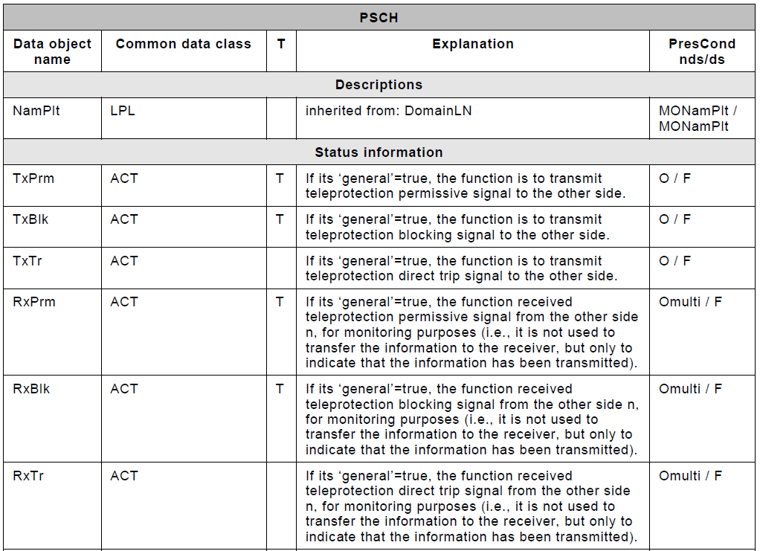
Thus, we need also to have some DO to represent:
- The possibility of remote closing of circuit breakers (related to power-plant connected via antenna to substation with a line with only one circuit breaker, or to specific automation functions associated to antenna lines).
- The possibility to prevent the closing of circuit breaker on the other side of the line. For example, in case of a mixt line (overhead-underground), if the fault is located on the underground section, we need to prevent the reclosing of circuit breaker in the overhead side.

