# MonetaryDatatypes in CIM

Date: 2025-05-08

## Terms and definitions

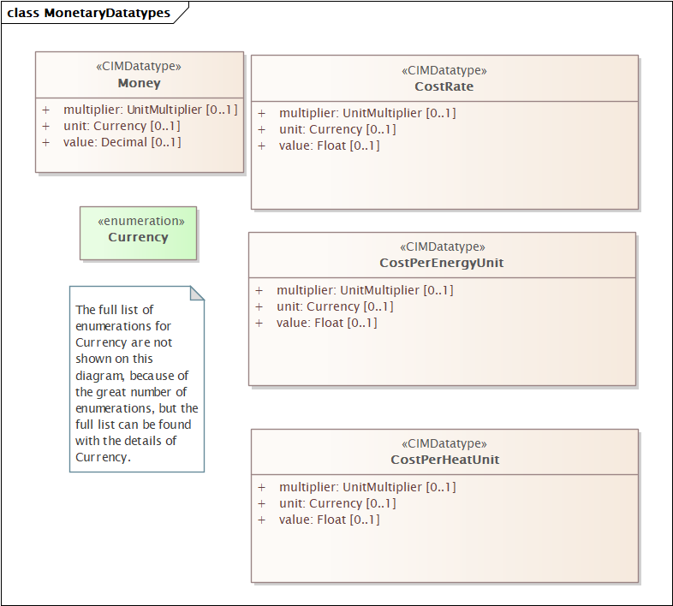

We have in previous meeting agreed to make the multiplier and unit fixed for Unit Datatype for CIM 18. This will not be possible for Money – as the Currency is not fixed.

One option is to have two attribute in any relevant class, currencyUnit:Currency and a separate value:Decimal.

Financial Industry Business Ontology (FIBO) is a Semantic web specification that is also addressing this. Here it if referred to as **MonetaryAmount**. The proposal is to <<deprecate>> Money and create a new MonetaryAmount class as <<Compound>> without multiplier.

In RDFS based profiles it is exchange as Compound with the use association. The same will work for other <<Compound>>. No changes for the XSD based serialization.

See [Define MonetaryDatatypes · Issue #28 · Sveino/CIM4Diagram](https://github.com/Sveino/CIM4Diagram/issues/28) for details.

The <<CIMDatatype>> CostRate, CostPerEnergyUnit and CostPerHeatUnit are not datatypes as they have multiple values that can be changes. They are also <<Compound>>.

CostPerHeatUnit is used for properties of Thermal Generation

CostRate, CostPerEnergyUnit  are used for properties of RegisteredGeneration.

If the attributes reflect a cost or benefit should be indicated in the attribute name, not in the CIMDatatype/Compound.

The proposal is to deprecate CostRate, CostPerEnergyUnit and CostPerHeatUnit and create a new Compound MonetaryRate that include the attributes currency and value (as float).

Proposal:

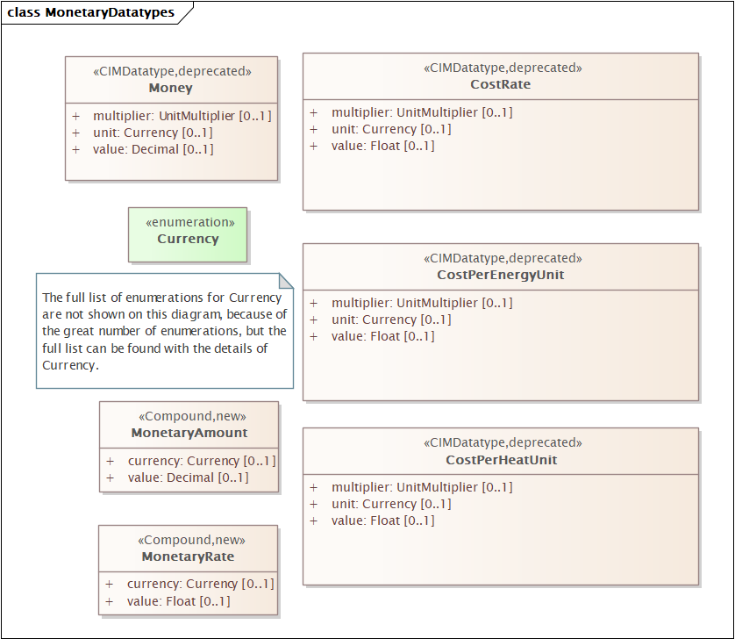

Related issue:

[CIM Issues #4688: Labels for the following 3 classes: MonetaryAmountPerEnergy - WG13 Issues - UCAIug Issue Tracking System](https://redmine.ucaiug.org/issues/4688)

[CIM Issues #3967: New datatype : CostPerVolume and a new Enumeration Monetary - WG13 Issues - UCAIug Issue Tracking System](https://redmine.ucaiug.org/issues/3967)

I could not find these classes and enumerators.

In **TF13 meeting 2025-05-08** it was suggested to replace the Currency (that is now not following the correct naming standard – should be CurrencyKind) with a Constrained Primitive, Currency

So, the updated proposal is then:

Deprecate the following classes:

* Money, Currency (enum), CostRate, CostPerEnergyUnit and CostPerHeatUnit

So that they are available and can be used in profiles that is currently using them with there is only adding new features to the updated profile.

Add two new <<Compound>>:

MonetaryAmount

Note: Amount of money in a currency.

MonetaryRate

Note: Monetary rate in a currency.

Create a Constrained Primitive,

**Currency Primitive**

Represents a Currency as a textual constraint, that refers a standardised currency code as, e.g. defined by ISO 4217. It identifies the type of currency used in a monetary amount or financial transaction. Example: "USD" – United States Dollar and "EUR" – Euro.

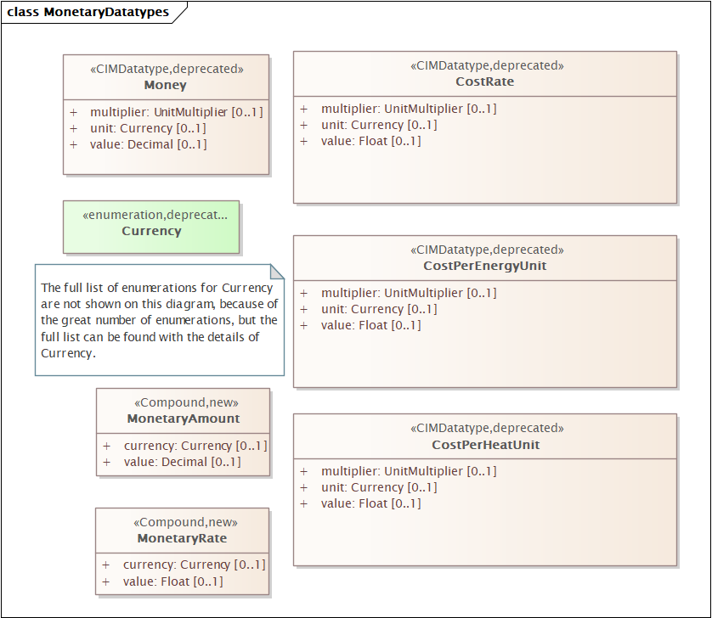

**Question**:

* Should we use "value" or "amount" and "rate" now when it is not a CIMDatatype?

**CMM Proposal 6/9/2025**

**Compound Class:** CostPerUnit

Description: Cost per unit rate as defined by the attribute rateUnit.

**Attributes:**

currency : The currency associated with the value.

rateMultiplier : The unit multiplier of the denominator which specifies the rate.

rateUnit : The unit of the denominator which specifies the rate.

value : The quantity in the numerator which specifies the cost.

**Alternative proposal from WG16**

**Compound Class:** MonetaryValuePerUnitOfMeasure

Description: Monetary value per commodity unit of measure as defined by the attribute commodityUnitOfMeasure. If energy is being traded, the commodityUnitOfMeasure should be “Wh” and the commodityUnitMultiplier could be “M”.

**Attributes:**

currency : The currency associated with the value.

commodityUnitMultiplier : The commodity unit multiplier of the denominator.

commodityUnitOfMeasure : The unit of measure of the commodity of the denominator.

monetaryValue(monetaryAmount) : The quantity in the numerator which specifies the monetary amount.