Name proposal

Date: 2025-03-23

Version: 1.0-alpha

Author: Svein Olsen

# Related Redmine issues

* mRID topics: [CIM Issues #5963: mRID topics [incl GMDM #19] - CIM Joint Issues - UCAIug Issue Tracking System](https://redmine.ucaiug.org/issues/5963)
* [CIM Issues #5978: Remove serialization instructions from the UML description of mRID - WG13 Issues - UCAIug Issue Tracking System](https://redmine.ucaiug.org/issues/5978)
* [CIM Issues #6630: Update Identity and naming description - WG13 Issues - UCAIug Issue Tracking System](https://redmine.ucaiug.org/issues/6630)
* [CIM Issues #6632: update definition of deprecated - WG13 Issues - UCAIug Issue Tracking System](https://redmine.ucaiug.org/issues/6632)
* [CIM Issues #6634: Simplify Name model using enum - WG13 Issues - UCAIug Issue Tracking System](https://redmine.ucaiug.org/issues/6634)
* … [maybe we have some more]

# Information model

The following is proposed as information model:

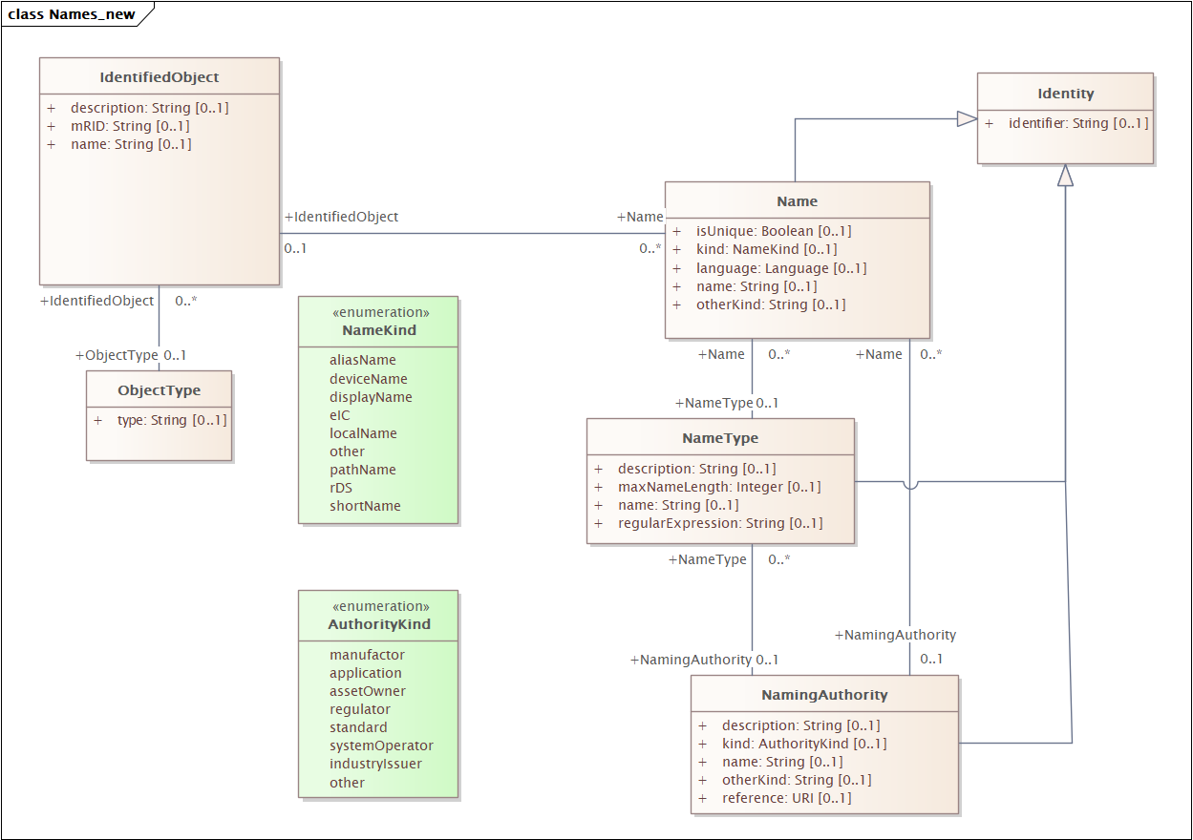

# Object Registry Profile

The information model can then be profiles to:

