**Proposal to accommodate tools which are in the dual role of ICT / SCT - Specific wording**

This regards <https://redmine.ucaiug.org/issues/6617>, and the existing proposal docx file attached.

There are three test cases, from 61850-10 Amd. 1 Ed. 2 draft:

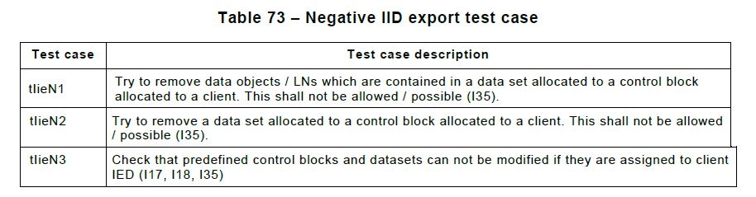

These are presumably derived from I35 in the 61850-6 SICS table:

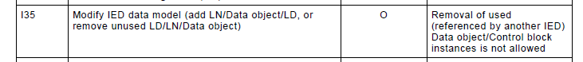

Proposed:

|  |  |  |
| --- | --- | --- |
| Item | Original | Proposal |
| I35 | "Removal of used (referenced by another IED) Data object/Control block instances is not allowed" | "...is either not possible, or produces a warning stating that this removal is not valid for an ICT when the SCD file is being managed by an external SCT." |
| tIieN1 | "...This shall not be allowed / possible (I35)" | "This shall either not be possible, or shall produce a warning stating that this removal is not valid for an ICT when the SCD file is being managed by an external SCT (I35)." |
| tIieN2 | "...This shall not be allowed / possible (I35)" | Same proposal as for tIieN1. |
| tIieN3 | "Check that predefined control blocks and datasets can not be modified if they are assigned to client IED (I17, I18, I35)" | "Try to modify predefined control blocks and datasets which are assigned to client IED. This shall either not be possible, or shall produce a warning stating that the modification is not valid for an ICT when the SCD file is being managed by an external SCT (I17, I18, I35)." |

And if these changes are accepted, then corresponding changes to the test procedure documents would be made as well.