# Proposal for CIM Auxiliary Loads

Version V0 01-Oct-2024 Tom Berry

CIM extensions to correspond to IEC 61850 equipment types: Fan, Pump, Motor, AuxiliarySupply

This part of the CIM models auxiliary loads such as the embedded motors of fans and pumps as part of the connectivity model. The operational status may be reported by real time data acquisition and included within topology and power flow analyses.

Cooling fans and pumps may be associated with primary power system equipment such as power transformers. The operational state of fans and pumps may affect the operational limits of the related primary power system equipment. These associations and dependencies are not part of the standard model.

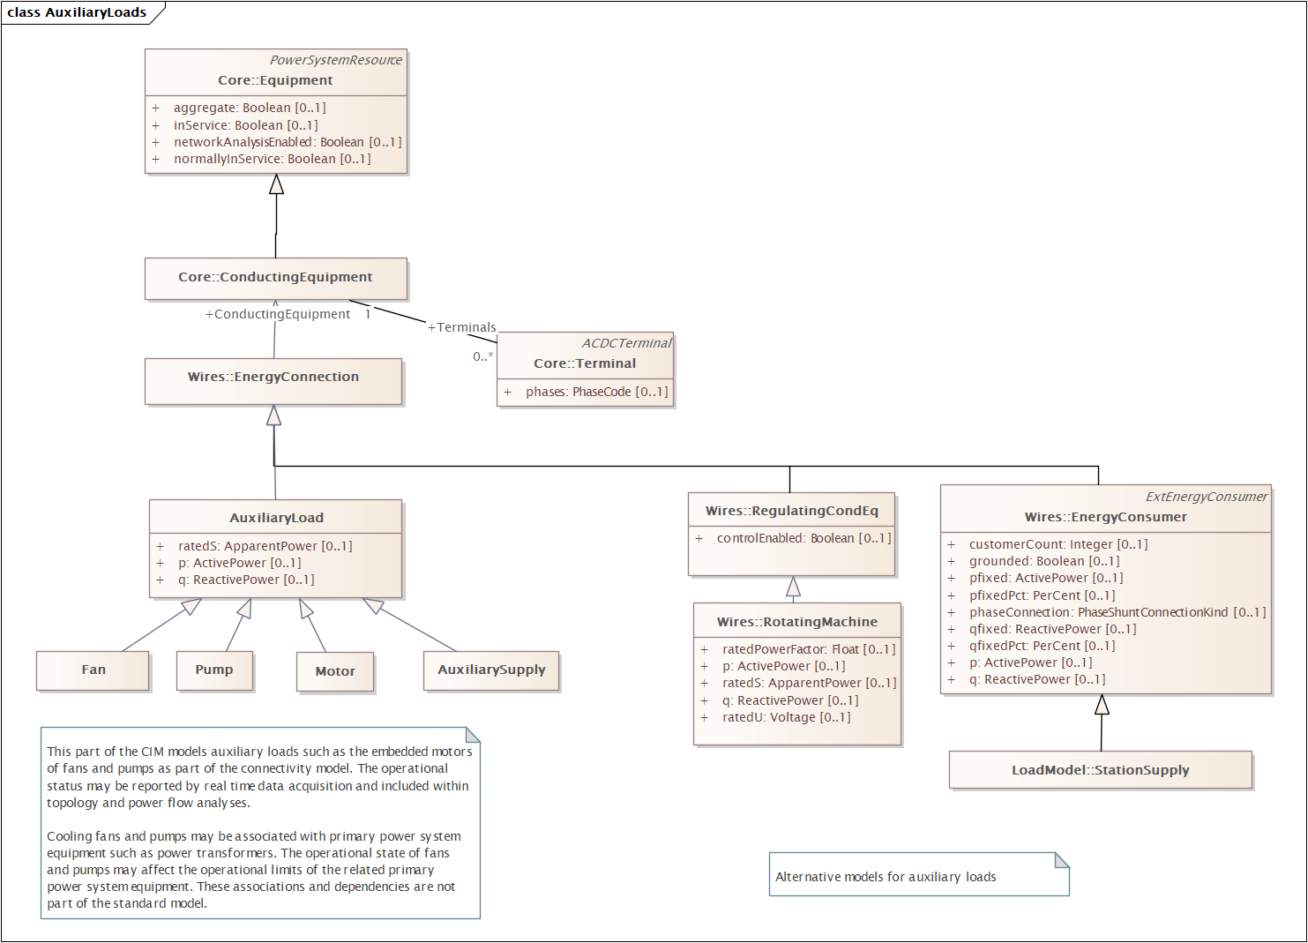

## Descriptions

**AuxiliaryLoad**

Fans, pumps and other electrically powered equipment. Typically with one terminal.

**Fan**

Machine designed to increase the pressure or kinetic energy of cooling air for a motor, transformer, etc. IEV 811-22-01

**Pump**

Machine for moving liquids. For example for transformers, a component that circulates insulating liquid through the cooling system and the transformer.

**Motor**

A machine which converts electrical energy into mechanical energy. IEV 411-33-01

**AuxiliarySupply**

Auxiliary power supply, e.g. for protection and automation equipment. Often including a backup battery and charger system.