**Proposal to accommodate tools which are in the dual role of ICT / SCT**

In regard to <https://redmine.ucaiug.org/issues/6617>, concerning tools being conformance tested in an ICT role that allow modification of data model or communications configuration. This is an outstanding discrepancy that hinders good engineering practices for tools with combined roles.

This regards three test cases, this is from 61850-10 Amd. 1 Ed. 2 draft:

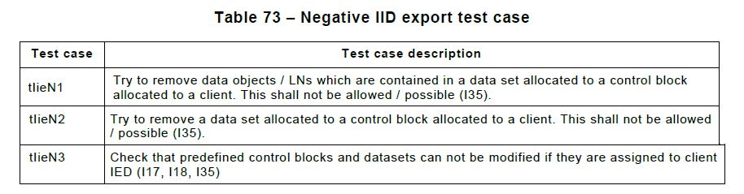

These are presumably derived from I35 in the 61850-6 SICS table:

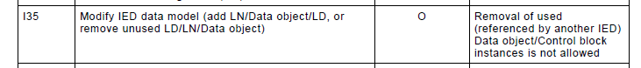

**Problem:** The issue is that some software tools act as both SCT and ICT, and when they are in the role of an SCT they can in fact freely modify the above items. Which creates a discrepancy when the same tool is also being submitted for ICT conformance. The SICS is currently more rigid than what is useful for users in this area. This is counter to the principle expressed in 61850-6:

* "NOTE It is not in the scope of this standard to define any details of concrete software tools, which support an engineer in doing the intended engineering process with SCL as described above...Each manufacturer is completely free to find the best way to support engineers by a specific software tool."

**Proposed:** The ideal implementation for users would be to provide a pop-up warning when they attempt to edit an item if the edit would alter or break any association that has already been made with a client.

Therefore, propose to change the above items from 61850-6 and 61850-10 to leave open two different options. Proposed rewording is as follows:

|  |  |  |
| --- | --- | --- |
| Item | Original | Proposal |
| I35 | "Removal of used (referenced by another IED) Data object/Control block instances is not allowed" | "...is either warned or is not allowed" |
| tIieN1 | "...This shall not be allowed / possible (I35)" | "This shall either not be allowed / possible, or shall create a specific warning (I35)" |
| tIieN2 |  | Same proposal as for tIi2N1. |
| tIieN3 | "Check that predefined control blocks and datasets can not be modified if they are assigned to client IED (I17, I18, I35)" | "Try to modify predefined control blocks and datasets which are assigned to client IED. This shall either not be allowed / possible, or shall create a specific warning (I17, I18, I35). |

And if these changes are accepted, then corresponding changes to the test procedure documents would be made as well.