Update 11 Apr 2024: Track changes address a gap found in the modelling of ConnectionAngleTapChanger

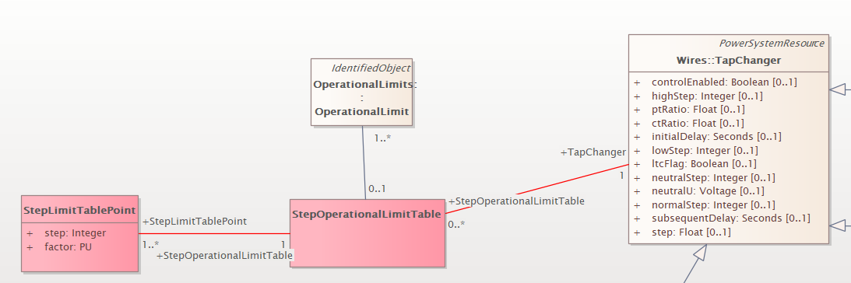

StepOperationalLimitTable - Describes a tabular curve for how the operational limit varies with the tap step.
StepLimitTablePoint - Describes each limit per step in the operational limit curve.
StepLimitTablePoint.step - The tap step.
StepLimitTablePoint.factor – The factor which is used to multiply the value of the operational limit associated with the table.
DECISIONS:
- We decided that this should be a float as opposed to PU.

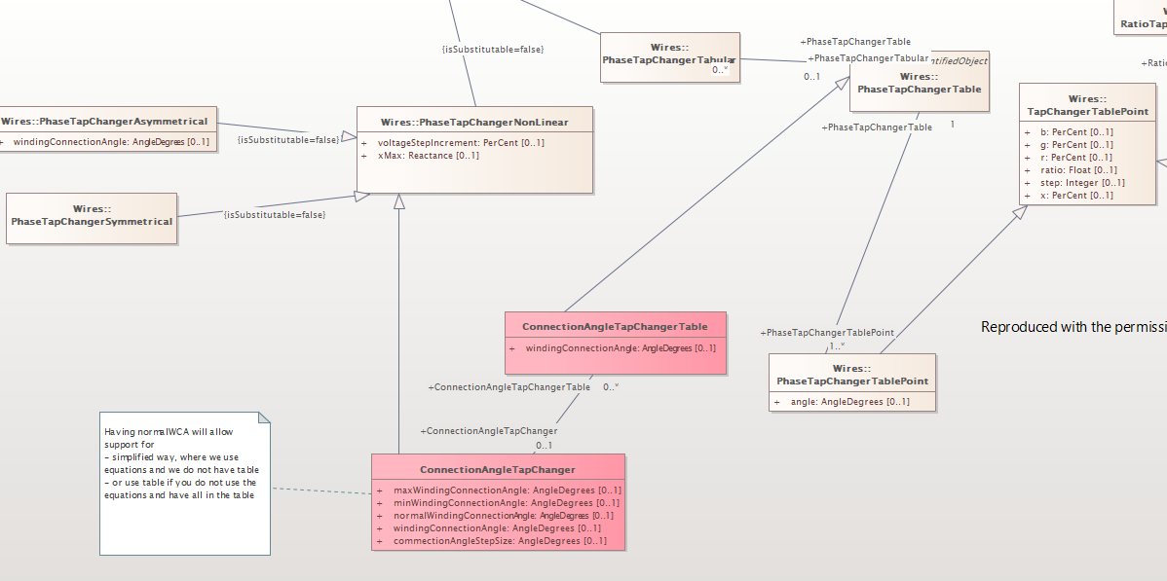
ConnectionAngleTapChangerTable - Describes a tabular curve for how the connection angle varies with the tap step. This table is used when its winding connection angle matches the operating angle of the tap changer. There must be an instance of this table for each winding connection angle that can be used.
ConnectionAngleTapChangerTable.windingConnectionAngle - The phase angle between the in-phase winding and the out-of -phase winding used for creating phase shift. The out-of-phase winding produces what is known as the difference voltage. Setting this angle to 90 degrees is not the same as a symmetrical transformer. In this scenario you will still treat the 90-degree angle as a phase shifting transformer. The attribute can only be multiples of 30 degrees. When 0 degree is used the asymmetrical phase tap changer acts as ratio tap changer controlling voltage.
ConnectionAngleTapChanger - Describes the tap model for an asymmetrical phase shifting transformer in which the difference voltage vector adds to the in-phase winding. The out-of-phase winding is the transformer end where the tap changer is located. The angle between the in-phase and out-of-phase windings is named the winding connection angle. The phase shift depends on both the difference voltage magnitude and the winding connection angle. The winding connection angle can be changed for different operating conditions while energized.
The following options are supported:
- Modelling of tap changer using ConnectionAngleTapChanger without ConnectionAngleTapChangerTable. Equations for asymmetrical transformer defined in IEC 61970-301 are used. The supported winding connection angle range is defined by the maximum winding connection angle and the minimum winding connection angle. The connection angle step size is used to define the allowed winding connection angles for the tap changer.
- Modelling of tap changer using ConnectionAngleTapChanger with ConnectionAngleTapChangerTable. There shall be different tables that relate to different winding connection angles that are supported by the tap changer. There is no need to provide information on winding connection angle range and connection angle step size as the allowed winding connection angles are defined by the table. The usage of the table is recommended in cases where the equations for asymmetrical transformer defined in IEC 61970-301 cannot fully describe the tap changer or in cases where it is exchange the data for different tap steps in an explicit way as a table.
ConnectionAngleTapChanger.minWindingConnectionAngle - The minimum phase angle between the in-phase winding and the out-of -phase winding used for creating phase shift. The attribute can be positive, negative or zero and can only be multiples of 30 degrees. When 0 degree is used the asymmetrical phase tap changer acts as ratio tap changer controlling voltage. When using connection angle tap changer table there is no need to provide information on winding connection angle range and connection angle step size as the allowed winding connection angles are defined by the table.
ConnectionAngleTapChanger.maxWindingConnectionAngle - The maximum phase angle between the in-phase winding and the out-of -phase winding used for creating phase shift. The attribute can be positive, negative or zero and can only be multiples of 30 degrees. When 0 degree is used the asymmetrical phase tap changer acts as ratio tap changer controlling voltage. The maximum winding connection angle shall be greater than the minimum winding connection angle. When using connection angle tap changer table there is no need to provide information on winding connection angle range and connection angle step size as the allowed winding connection angles are defined by the table.
ConnectionAngleTapChanger.connectionAngleStepSize – The supported winding connection angle range is defined by the maximum winding connection angle and the minimum winding connection angle. The connection angle step size is used to define the allowed winding connection angles for the tap changer. The attribute shall be a positive value and can only be multiples of 30 degrees. For example, if the tap changer has maximum winding connection angle equal to 60 degrees, minimum winding connection angle equal to -60 degrees and the connection angle step size is equal to 60, the allowed winding connection angle that can be used for this tap changer are -60 degrees, 0 degrees and -60 degrees. When using connection angle tap changer table there is no need to provide information on winding connection angle range and connection angle step size as the allowed winding connection angles are defined by the table.
ConnectionAngleTapChanger.windingConnectionAngle - The operating phase angle between the in-phase winding and the out-of -phase winding used for creating phase shift. The out-of-phase winding produces what is known as the difference voltage. Setting this angle to 90 degrees is not the same as a symmetrical transformer. In this scenario you will still treat the 90-degree angle as a phase shifting transformer. The attribute can only be multiples of 30 degrees. When 0 degree is used the asymmetrical phase tap changer acts as ratio tap changer controlling voltage.
ConnectionAngleTapChanger.normalWindingConnectionAngle - The normal phase angle between the in-phase winding and the out-of -phase winding used for creating phase shift. The out-of-phase winding produces what is known as the difference voltage. Setting this angle to 90 degrees is not the same as a symmetrical transformer. In this scenario you will still treat the 90-degree angle as a phase shifting transformer. The attribute can only be multiples of 30 degrees. When 0 degree is used the asymmetrical phase tap changer acts as ratio tap changer controlling voltage.

Question: can we actually inherit ConnectionAngleTapChanger from PhaseTapChangerAsymmetrical, so that we do not duplicate windingConnectionAngle? If we do this we need to take care that 0 deg is allowed for ConnectionAngleTapChanger but not allowed for PhaseTapChangerAsymmetrical.

DECISION: We will not apply the above suggest change because the one in the super class is the normal value and not the operation value.

Modelling options – This is already integrated in the description of the classes
- Model PhaseTapChangerTabular with ConnectionAngleTapChangerTable.
- Model ConnectionAngleTapChanger without ConnectionAngleTapChangerTable. Equations for asymmetrical transformer defined in IEC 61970-301 are used. ConnectionAngleTapChanger.normalWindingConnectionAngle is exchanged in the EQ profile and ConnectionAngleTapChanger.windingConnectionAngle is exchanged in SSH which enables to change the winding connection angle between operating points
- Model ConnectionAngleTapChanger with ConnectionAngleTapChangerTable. There should be different tables that relate to different windingConnectionAngle.

DECISION: The above modelling options should be fine in lieu of updates we made earlier in this document.
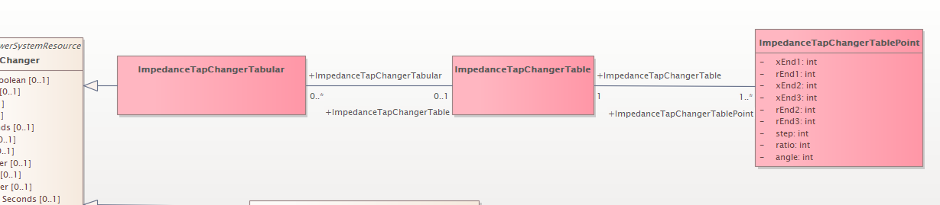
ImpedanceTapChangerTabular - Describes a tap changer with a table defining the relation between the tap step and the impedance difference across the windings of a three winding transformer.

ImpedanceTapChangerTable - Describes a curve for how the power transformer end impedance varies with the tap step.

ImpedanceTapChangerTablePoint - Describes each tap step in the impedance tap changer tabular curve.

ImpedanceTapChangerTablePoint.xEnd1 - The series reactance deviation as a percentage of nominal value, x(nominal), for the winding with TransformerEnd.endNumber equal to 1. The actual reactance is calculated as follows: calculated reactance = x(nominal) * (1 + x (from this class)/100). This model assumes the star impedance (pi model) form. Note that the upper boundary is not constrained to 100 percent.
ImpedanceTapChangerTablePoint.xEnd2 - The series reactance deviation as a percentage of nominal value, x(nominal), for the winding with TransformerEnd.endNumber equal to 2. The actual reactance is calculated as follows: calculated reactance = x(nominal) * (1 + x(from this class)/100). This model assumes the star impedance (pi model) form. Note that the upper boundary is not constrained to 100 percent.
ImpedanceTapChangerTablePoint.xEnd3 - The series reactance deviation as a percentage of nominal value, x(nominal), for the winding with TransformerEnd.endNumber equal to 3. The actual reactance is calculated as follows: calculated reactance = x(nominal) * (1 + x(from this class)/100). This model assumes the star impedance (pi model) form. Note that the upper boundary is not constrained to 100 percent.
ImpedanceTapChangerTablePoint.rEnd1 - The resistance deviation as a percentage of nominal value, r(nominal), for the winding with TransformerEnd.endNumber equal to 1. The actual reactance is calculated as follows: calculated resistance = r(nominal) * (1 + r(from this class)/100). This model assumes the star impedance (pi model) form. Note that the upper boundary is not constrained to 100 percent.
ImpedanceTapChangerTablePoint.rEnd2 - The resistance deviation as a percentage of nominal value, r(nominal), for the winding with TransformerEnd.endNumber equal to 2. The actual reactance is calculated as follows: calculated resistance = r(nominal) * (1 + r(from this class)/100). This model assumes the star impedance (pi model) form. Note that the upper boundary is not constrained to 100 percent.
ImpedanceTapChangerTablePoint.rEnd3 - The resistance deviation as a percentage of nominal value, r(nominal), for the winding with TransformerEnd.endNumber equal to 3. The actual reactance is calculated as follows: calculated resistance = r(nominal) * (1 + r(from this class)/100). This model assumes the star impedance (pi model) form. Note that the upper boundary is not constrained to 100 percent.
ImpedanceTapChangerTablePoint.step - The tap step.
ImpedanceTapChangerTablePoint.ratio - The voltage at the tap step divided by rated voltage of the transformer end having the tap changer. Hence this is a value close to one. For example, if the ratio at step 1 is 1.01, and the rated voltage of the transformer end is 110kV, then the voltage obtained by setting the tap changer to step 1 to is 111.1kV.
ImpedanceTapChangerTablePoint.angle - The angle difference in degrees. A positive value indicates a positive angle variation from the Terminal at the PowerTransformerEnd, where the TapChanger is located, into the transformer.

DECISIONS / RECOMMENDATIONS:
  - The sentence “Note that the upper boundary is not constrained to 100 percent.” Should be added to the existing TapChangeTabularTable descriptions for attributes b, g, r, and x while adding the new attributes:
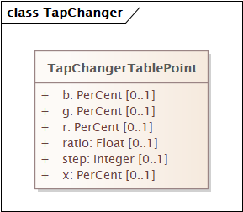
  - Whoever it is that has submitted this new tap change type will need to double check the namespace to determine if a b and g is listed on the nameplate and does it vary with the tap changer. If there is, then we should add these attributes as well to the new tables.
  - These are approved for inclusion in CIM18.

