Solution to redmine 6489

GOOSE performance resources
Jan 23, 2024
Clarify that only one element need to be processed from each subscribed GOOSE message.
Fixed the title of 4.1.3 in the solution: Extract from the TP 2.5 is correct, no change needed:
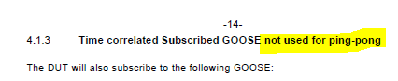

Subscribed GOOSE used for ping-pong
The DUT will subscribe to at least one element from each of the following GOOSE:
Dataset normal dataset = 4 Boolean data values and 4 qualities
Structure normal dataset:
(bool1, q1, bool2, q2, bool3, q3, bool4, q4)
large dataset = 20 Boolean values with qualities and 20 DP values with qualities.
Structure large dataset:
(bool1, q1, bool2, q2, …., bool20, q20, DP1, q1, DP2, q2, ….,DP20, q20)

Time correlated Subscribed GOOSE not used for ping-pong
The DUT will subscribe to at least one element from each of the following GOOSE:

In case the DUT does not support 20 Boolean or 20 DP, or the DUT has some limitations regarding dataset size, the LARGE Dataset shall contain at least 40 values and 40 qualities or the maximum number of dataset entries that is possible according to the description in PIXIT.

