SubstationKind
Date: 2023-11-30
Version: 0.9
Redmine issue: CIM Issues #6616: Add SubstationKind - WG13 Issues - UCAIug Issue Tracking System
Contents
SubstationKind 1
UML Information model (61970-301:2020 (CIM17)) 1
UML Information model (61968-11 (CIM17v40)) 2
FacilityKind enumeration 3
Justification to include SubstationKind 4
US Department of Energy (DoE) 4
Norwegian and Statnett extension for SubstationKind 5
IEC standard and Electropedia 5
Proposed SubstationKind 8

UML Information model (61970-301:2020 (CIM17))
Currently there are no classification of the Substation:
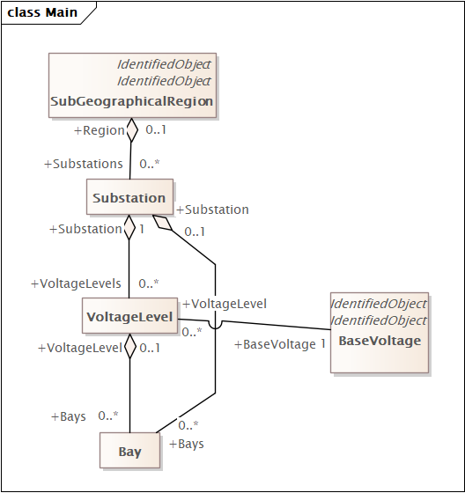

UML Information model (61968-11 (CIM17v40))
In Asset Lifecycle we have AssetDeployment that have a faiclityKind that do refer to different type of substation.
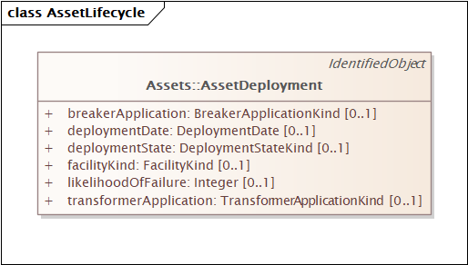
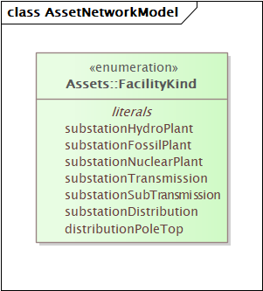

FacilityKind enumeration
Types of facilities at which an asset can be deployed.
Table 278 shows all literals of FacilityKind.
Table 278 – Literals of Assets::FacilityKind
literal | value | description
substationHydroPlant |  | Hydro plant substation.
substationFossilPlant |  | Fossil plant substation.
substationNuclearPlant |  | Nuclear plant substation.
substationTransmission |  | Transmission substation.
substationSubTransmission |  | Subtransmission substation.
substationDistribution |  | Distribution substation.
distributionPoleTop |  | Distribution pole top.
The description is not particularly useful and should be updated. I do not think this is the right place to provide this type of information. The substation classification is very relevant as part of getting the initial license to build the substation and are therefore particularly relevant as part of the design.

Justification to include SubstationKind
Adding SubstationKind to the information model does not automatically require to be added to the 61970-452 EQ profile. However, we should create a profile where this information could be exchanged.
There are multiple sources that describe the relevance of classifying the substation into kind. Listed are information from a resource paper from US Department of Energy as an example. I have also included on the extension that is used in Norway and at Statnett.
However, most relevant is to align this with the IEC standards. I have therefore included relevant link to Electropedia.

US Department of Energy (DoE)
Office of Electricity TRAC Program - Solid State Power Substation Technology Roadmap: Microsoft Word - 2020 Solid State Power Substation Technology Roadmap (energy.gov)
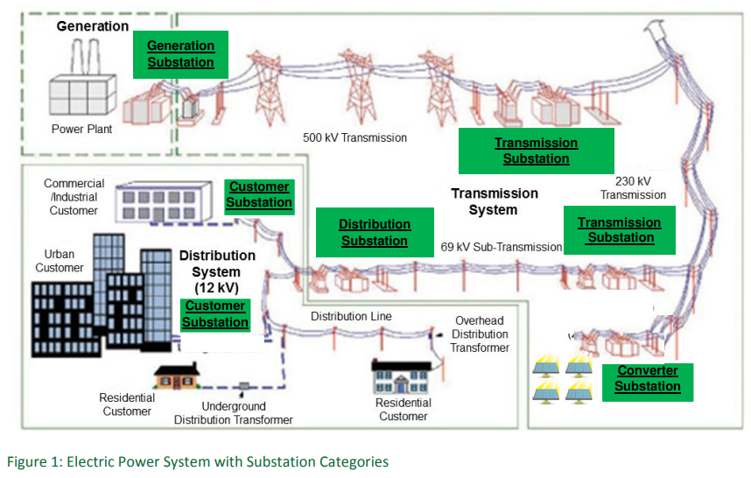
As CIM shall work for Generation, transmission, distribution and facility (consumer or rather Procumers) it is important that we do not do any categorisation based on a particular viewpoint. This excludes the use of Customer, distribution and transmission.

Norwegian and Statnett extension for SubstationKind
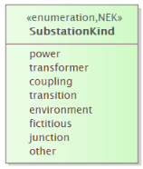
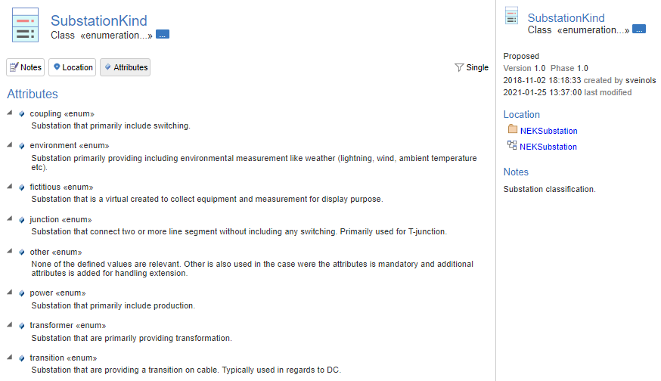
Environment and fictious should be address by allowing measurement to be provided by Power System Resource that is not embed in a substation. It is a question if "junction" is need, but as many vendors does not support cim:Junction and cim:Line that goes between three or more substation, there might still be a need for using a substation as junction.

IEC standard and Electropedia
The list of Electropedia terms that include Substation are:
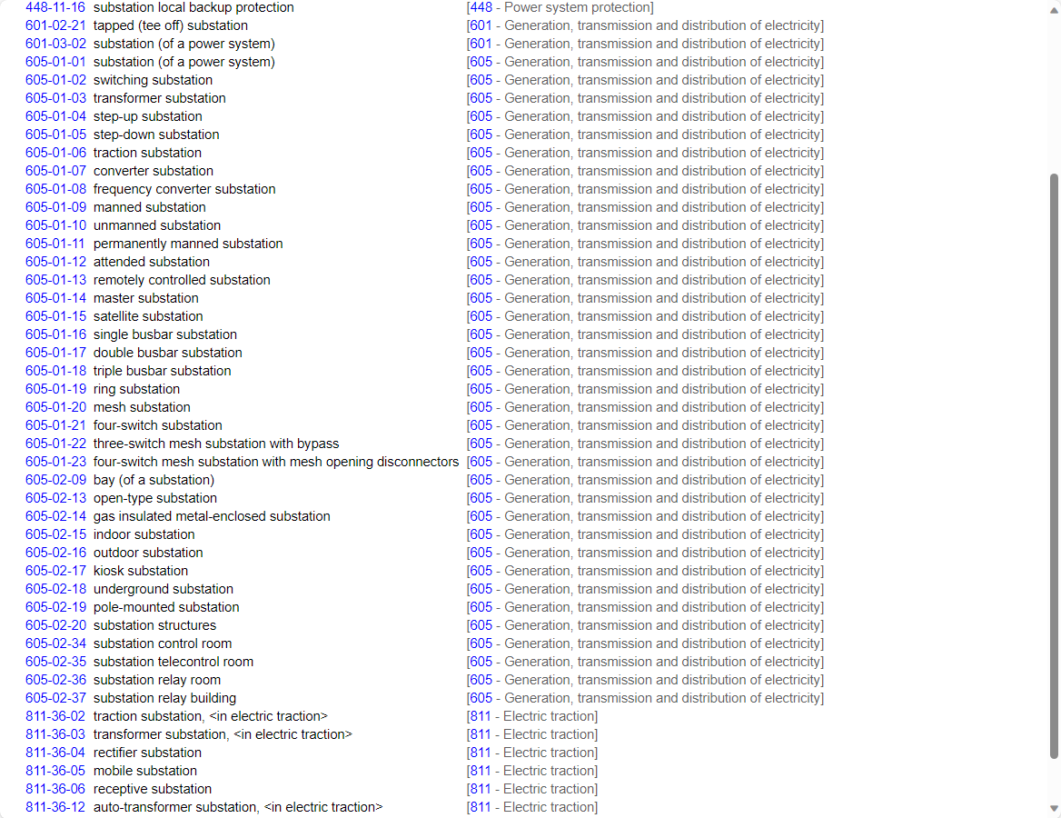
We have two definitions of substation of a power system:
"
substation (of a power system)
a part of an electrical system, confined to a given area, mainly including ends of transmission or distribution lines, electrical switchgear and controlgear, buildings and transformers. A substation generally includes safety or control devices (for example protection)
Note – The substation can be qualified according to the designation of the system of which it forms a part. Examples: transmission, substation (transmission system), distribution substation, 400 kV or 20 kV substation.
IEC 60050 - International Electrotechnical Vocabulary - Details for IEV number 601-03-02: "substation (of a power system)" (electropedia.org)
substation (of a power system)
the part of a power system, concentrated in a given place, including mainly the terminations of transmission or distribution lines switchgear and housing and which may also include transformers. It generally includes facilities necessary for system security and control (e.g. the protective devices)
Note – According to the nature of the system within which the substation is included, a prefix may qualify it.
Examples: transmission substation (of a transmission system), distribution substation, 400 kV substation, 20 kV substation.
IEC 60050 - International Electrotechnical Vocabulary - Details for IEV number 605-01-01: "substation (of a power system)" (electropedia.org)

The following are relevant definition for the categorisation of s substation in a power system:
switching substation
a substation which includes switchgear and usually busbars, but no power transformers
IEC 60050 - International Electrotechnical Vocabulary - Details for IEV number 605-01-02: "switching substation" (electropedia.org)
transformer substation
a substation containing power transformers interconnecting two or more networks of different voltages
IEC 60050 - International Electrotechnical Vocabulary - Details for IEV number 605-01-03: "transformer substation" (electropedia.org)
step-up substation
a transformer substation in which the outgoing power from the transformers is at a higher voltage than the incoming power
IEC 60050 - International Electrotechnical Vocabulary - Details for IEV number 605-01-04: "step-up substation" (electropedia.org)
step-down substation
a transformer substation in which the outgoing power from the transformers is at a lower voltage than the incoming power
IEC 60050 - International Electrotechnical Vocabulary - Details for IEV number 605-01-05: "step-down substation" (electropedia.org)
traction substation
a substation, the main function of which is to supply a traction system
IEC 60050 - International Electrotechnical Vocabulary - Details for IEV number 605-01-06: "traction substation" (electropedia.org)
converter substation
a substation including converters and the main function of which is to convert alternating current into direct current or vice versa
IEC 60050 - International Electrotechnical Vocabulary - Details for IEV number 605-01-07: "converter substation" (electropedia.org)
frequency converter substation
substation in which an alternating current at a given frequency is converted into an alternating current at another frequency
IEC 60050 - International Electrotechnical Vocabulary - Details for IEV number 605-01-08: "frequency converter substation" (electropedia.org)

Proposed SubstationKind
Base on the above information, the following enumeration items are proposed.
– Literals of Core::SubstationKind
literal | value | description
switching |  | substation which includes switchgear and usually busbars, but no power transformers
transformer |  | substation containing power transformers interconnecting two or more networks of different voltages
step-up (alt stepUp or generation) |  | transformer substation in which the outgoing power from the transformers is at a higher voltage than the incoming power
step-down (alt stepDown or facility) |  | transformer substation in which the outgoing power from the transformers is at a lower voltage than the incoming power
traction |  | substation, the main function of which is to supply a traction system
converter |  | substation including converters and the main function of which is to convert alternating current into direct current or vice versa
frequencyConverter |  | substation in which an alternating current at a given frequency is converted into an alternating current at another frequency
junction |  | substation which connects two or more line segment without including switchgear. Typically, a representation of a T-junction.
other |  | None of the defined value are relevant.

