# Measurement and Control

Date: 2023-11-27

Version: 0.6

Redmine issue: [CIM Issues #6610: Multiple issue Measurement and Control - WG13 Issues - UCAIug Issue Tracking System](https://redmine.ucaiug.org/issues/6610)

Contents

Measurement and Control 1

Background 1

IEC 61970-301 (ED7) CIM17 - Measurement 2

1.1.1 Quality61850 root class 5

IEC 61968 – AssetHealthMeasurement 6

IEC 62325 – EnvironmentalMeasurement 9

IEC 61970-301 (ED7) CIM17 - Control 11

IEC 61970-301 (ED7) CIM17 - SCADA 12

IEC 61970-452 (ED5) CIM17 - Operation 13

Requirement for Change 18

## Background

We have had a lot of discussion in IEC CIM working groups regarding Measurement. From the Joint In-Person meeting in Minneapolis we had an agreement that we should look into creating a "new" Measurement, sensor data and observation model that would be a superset of all the requirement related to:

* SCADA
* 61850 - harmonisation
* Meter reading (this has now been changed from manual reading once a month to schedule or event-based reading)
* Environment observation
* PMUs
* Internet-of-things (IoT)
* Asset health

To move to this new structure would be breaking changes from existing profile. So the plan is that the existing model and profile are kept, until it is sure that the new structure are fully supporting the old and there will be benefit to mover from the old profile/structure to the new.

So this Change Request for CIM18 does not address the full scope, but suggesting changes that is needed for the Operation Profile (IEC 61970-452 OperationProfile) to be used efficient with the current scope.

## IEC 61970-301 (ED7) CIM17 - Measurement

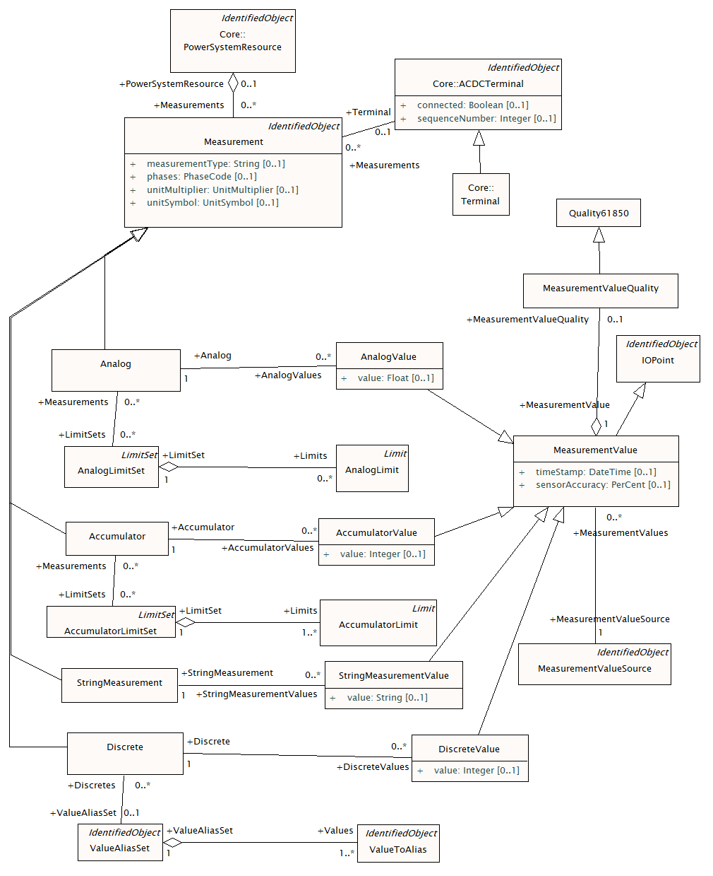

Table 6 – measurementType naming conventions

|  |  |  |
| --- | --- | --- |
| measurementType | 61850 Name | description |
| Current | Amp | Current (rms) of a non-three phase circuit |
| ThreePhaseCurrent | AvAmps | Total current (rms) in a three phase circuit |
| PhaseCurrent | A | Measured phase current. |
| Frequency | Hz | Frequency |
| PowerFactor | PwrFact | Power factor not allocated to a phase |
| ThreePhasePowerFactor | TotPF | Average power factor in a three phase circuit |
| ThreePhaseApparentPower | TotVA | Total apparent power in a three phase circuit |
| ThreePhaseReactivePower | TotVAr | Total reactive power in a three phase circuit |
| ThreePhaseActivePower | TotW | Total real power in a three phase circuit. |
| ApparentPower | VolAmp | Apparent power in a non-three phase circuit |
| ReactivePower | VolAmpr | Reactive power in a non-three phase circuit |
| Voltage | Vol | Voltage (rms) not allocated to a phase |
| ActivePower | Watt | Real power in a non-three phase circuit |
| Pressure | Pres | Pressure |
| Temperature | Tmp | Temperature |
| Angle | Ang | Angle between voltage and current |
| ApparentEnergy | TotVAh | Apparent energy |
| ReactiveEnergy | TotVArh | Reactive energy |
| ActiveEnergy | TotWh | Real energy |
| Automatic | Auto | Automatic operation (not manual) |
| LocalOperation | Loc | Local operation (not remote) |
| SwitchPosition | Pos | Switch position  [2bits= intermediate,open,closed,ignore] |
| TapPosition | TapPos | Tap position of power transformer or phaseshifter |
| Operation Count | OperCnt | Operation count – typically for switches |
| LineToNeutralVoltage |  | Line to neutral voltage. |
| LineToGroundVoltage |  | Line to ground voltage. |
| Specialization |  | Used when a specialization of the Analog class defines the type of measurement rather than the Measurement.measurementType attribute. |

Table 6 describes various types of measurements also defined in IEC 61850. The meanings of the columns in Table 6 are as follows:

* measurementType (Measurement.measurementType) is the IEC 61970 measurement type name.
* 61850 Name is the name assigned to the data object in IEC 61850. IEC 61850-7-4:2010, data object name semantics).
* description is the description of the data.

It shall be noted that Table 6 is not an exhaustive list and that the mapping between measurements as defined in a control centre and a substation is non-trivial.

Table 7 – MeasurementValueSource naming conventions

| Name | description |
| --- | --- |
| SCADA | Telemetered values received from a local SCADA system |
| CCLink | Value received from a remote control centre via TASE.2 or other control centre protocol |
| Operator | Operator entered value (always manually maintained, PSR is not connected to an RTU) |
| Estimated | Value updated by a state estimator |
| PowerFlow | Value updated as result of a Powerflow |
| Forecasted | Value that is planned or forecasted. |
| Calculated | Calculated from other measurement values (e.g. a sum) |
| Allocated | Calculated by a load allocator |

Following these conventions:

* each Measurement instance represents a technological quantity of a PowerSystemResource;
* each MeasurementValue of a Measurement represents a value for the technological quantity, as supplied from a single source;
* the source attribute in MeasurementValueQuality then indicates whether the source actually provided the current value, or whether it had been substituted or defaulted.

Note that a new MeasurementValue identity is not normally created for each exchange of a measured value. It is expected that the same MeasurementValue instance could exchange new values in subsequent messages. Therefore the identity of a MeasurementValue instance can be established apriori to exchange of measured values. The modelling of a time series of values is not explicitly expressed in the CIM model, though the model allows for systems to internally build such time series models through a series of measurement value exchanges.

#### Attachment of measurements

As mentioned in 4.5.11.3 and as shown in Figure 34, Measurements are contained by a PowerSystemResource. This is sufficient for Measurements that are not related to connectivity, e.g. temperature, weight, size.

To specify the location of a Measurement in the network, an association to Terminal is used. Examples include power flows, voltages, and currents. Voltages have no direction and can be attached wherever appropriate in relation to the sensor placement. Flows have direction and shall be attached such that the flow direction is evident from the placement.

Figure 35 shows two examples of the placement of Measurements.



Figure 35 - Measurement placement

P12 is a voltage Measurement that measures the voltage at the Junction J1. P12 is topologically related to the ConnectivityNode CN1 via the Terminal in Junction J1. P11 is a Measurement that measures the flow through Breaker BR10 at the side connected to the ConnectivityNode CN1. P11 is topologically related to the ConnectivityNode CN1 via the left Terminal in Breaker BR10. Temp is a Measurement that measures the Breaker temperature. As a temperature is not related to connectivity, it has no relation to a Terminal – it just belongs to the Breaker BR10.

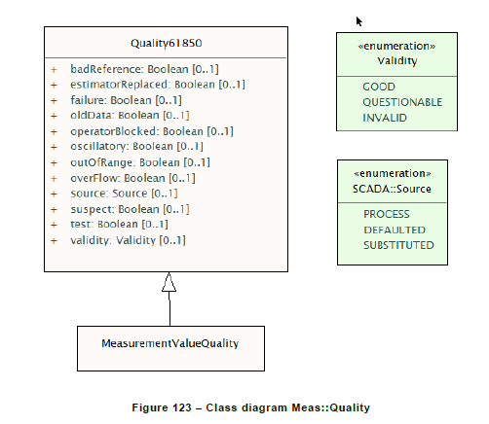

### Quality61850 root class

Quality flags in this class are as defined in IEC 61850, except for estimatorReplaced, which has been included in this class for convenience.

Table 602 shows all attributes of Quality61850.

Table 602 – Attributes of Meas::Quality61850

| name | mult | type | description |
| --- | --- | --- | --- |
| badReference | 0..1 | Boolean | Measurement value may be incorrect due to a reference being out of calibration. |
| estimatorReplaced | 0..1 | Boolean | Value has been replaced by State Estimator. estimatorReplaced is not an IEC61850 quality bit but has been put in this class for convenience. |
| failure | 0..1 | Boolean | This identifier indicates that a supervision function has detected an internal or external failure, e.g. communication failure. |
| oldData | 0..1 | Boolean | Measurement value is old and possibly invalid, as it has not been successfully updated during a specified time interval. |
| operatorBlocked | 0..1 | Boolean | Measurement value is blocked and hence unavailable for transmission. |
| oscillatory | 0..1 | Boolean | To prevent some overload of the communication it is sensible to detect and suppress oscillating (fast changing) binary inputs. If a signal changes in a defined time twice in the same direction (from 0 to 1 or from 1 to 0) then oscillation is detected and the detail quality identifier "oscillatory" is set. If it is detected a configured numbers of transient changes could be passed by. In this time the validity status "questionable" is set. If after this defined numbers of changes the signal is still in the oscillating state the value shall be set either to the opposite state of the previous stable value or to a defined default value. In this case the validity status "questionable" is reset and "invalid" is set as long as the signal is oscillating. If it is configured such that no transient changes should be passed by then the validity status "invalid" is set immediately in addition to the detail quality identifier "oscillatory" (used for status information only). |
| outOfRange | 0..1 | Boolean | Measurement value is beyond a predefined range of value. |
| overFlow | 0..1 | Boolean | Measurement value is beyond the capability of being  represented properly. For example, a counter value overflows from maximum count back to a value of zero. |
| source | 0..1 | Source | Source gives information related to the origin of a value. The value may be acquired from the process, defaulted or substituted. |
| suspect | 0..1 | Boolean | A correlation function has detected that the value is not consistent with other values. Typically set by a network State Estimator. |
| test | 0..1 | Boolean | Measurement value is transmitted for test purposes. |
| validity | 0..1 | Validity | Validity of the measurement value. |

## IEC 61968 – AssetHealthMeasurement

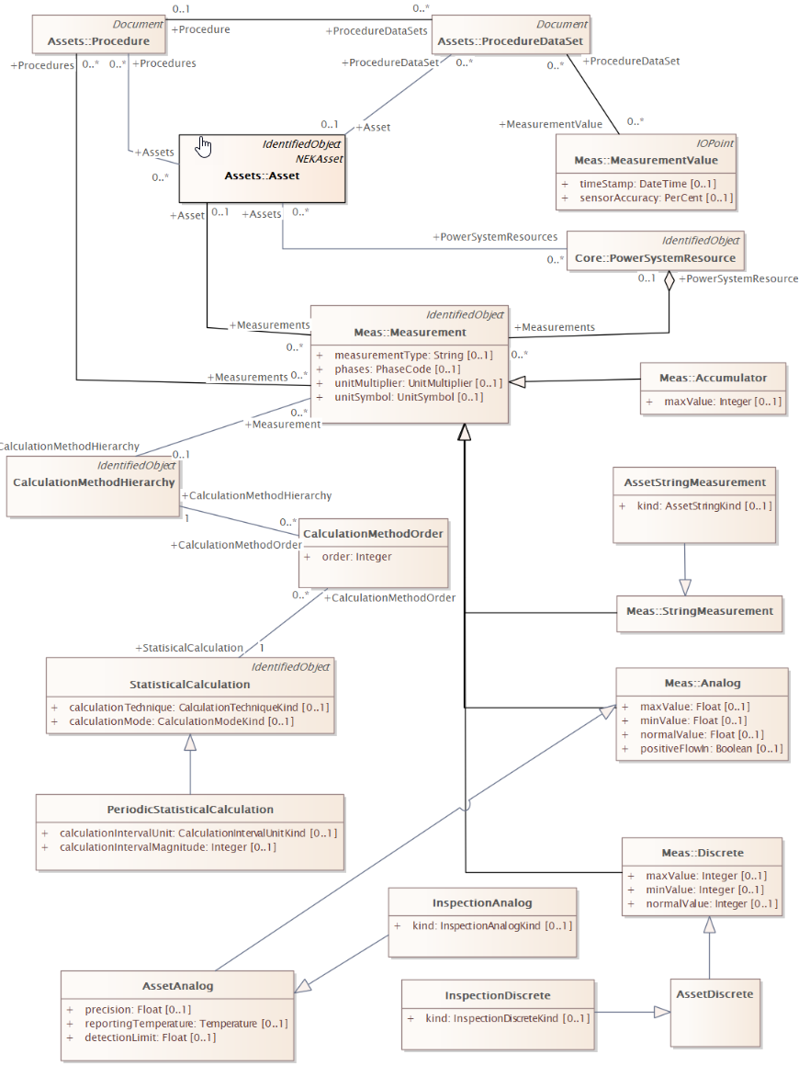

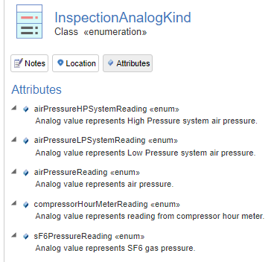

## IEC 62325 – EnvironmentalMeasurement

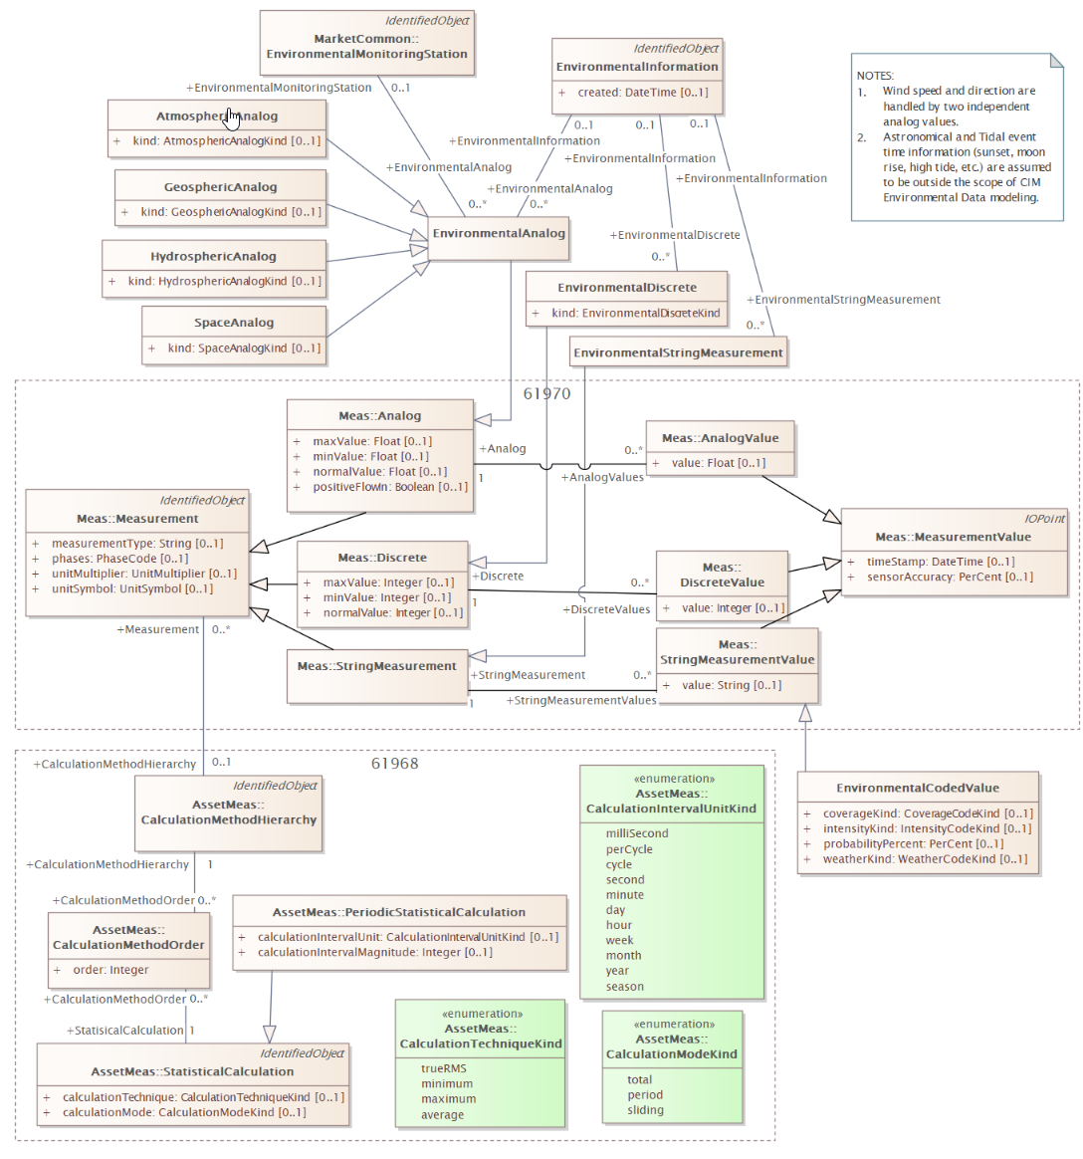

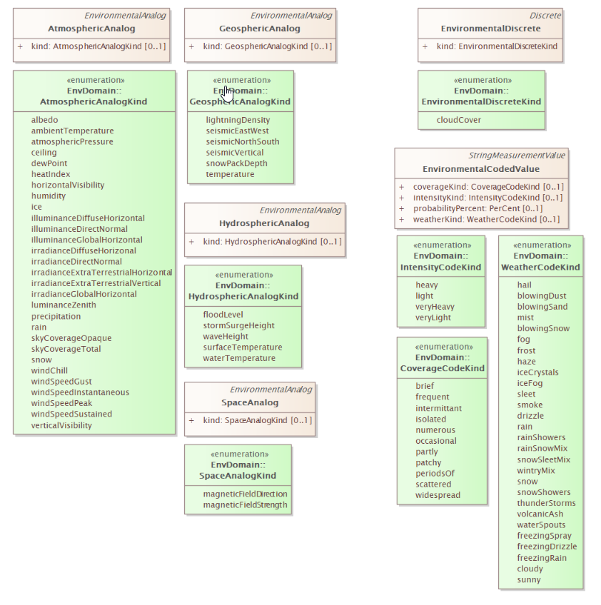

## IEC 61970-301 (ED7) CIM17 - Control

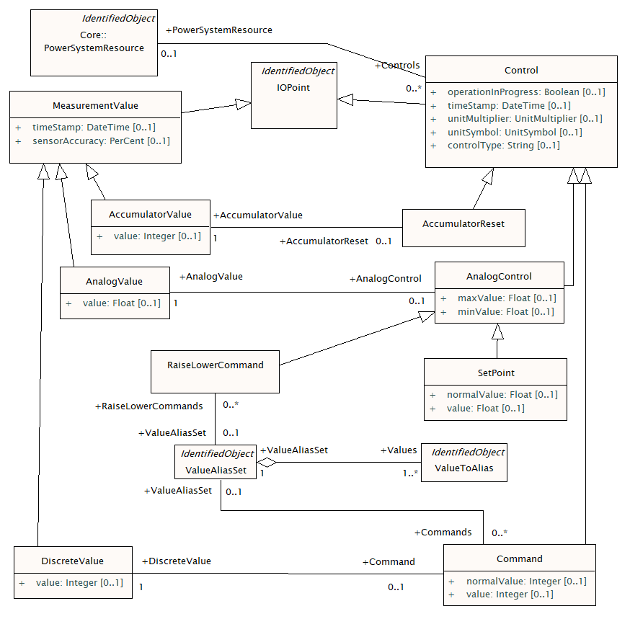

Table 582 shows all attributes of Control.

Table 582 – Attributes of Meas::Control

| name | mult | type | description |
| --- | --- | --- | --- |
| operationInProgress | 0..1 | Boolean | Indicates that a client is currently sending control commands that has not completed. |
| timeStamp | 0..1 | DateTime | The last time a control output was sent. |
| unitMultiplier | 0..1 | UnitMultiplier | The unit multiplier of the controlled quantity. |
| unitSymbol | 0..1 | UnitSymbol | The unit of measure of the controlled quantity. |
| controlType | 0..1 | String | Specifies the type of Control, e.g. BreakerOn/Off, GeneratorVoltageSetPoint, TieLineFlow etc. The ControlType.name shall be unique among all specified types and describe the type. |
| aliasName | 0..1 | String | inherited from: IdentifiedObject |
| description | 0..1 | String | inherited from: IdentifiedObject |
| mRID | 0..1 | String | inherited from: IdentifiedObject |
| name | 0..1 | String | inherited from: IdentifiedObject |

## IEC 61970-301 (ED7) CIM17 - SCADA

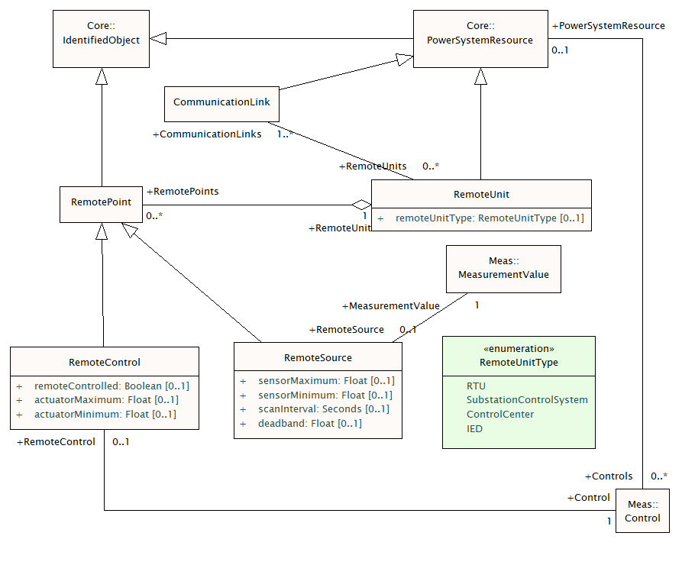

## IEC 61970-452 (ED5) CIM17 - Operation

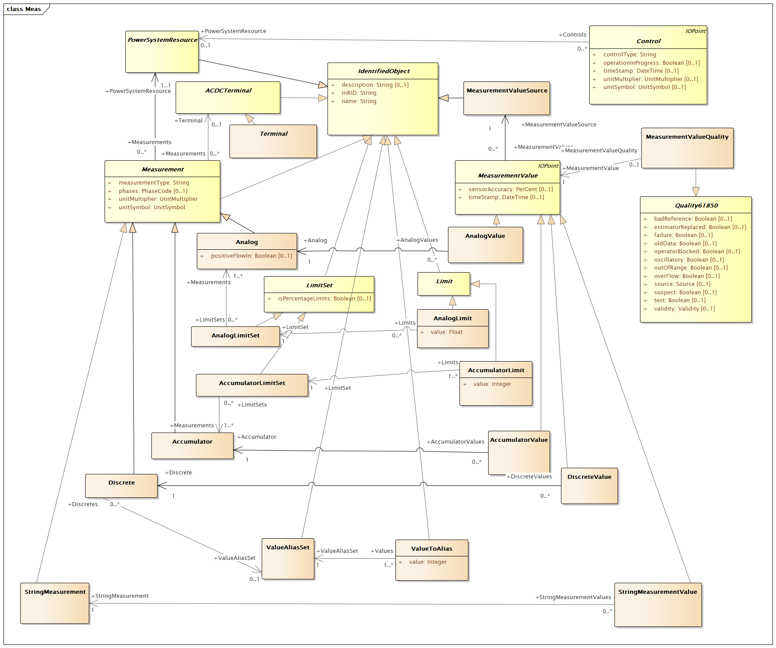

Figure 29 – Class diagram OperationProfile::Meas

Table 436 – Valid attribute values

|  |  |  |
| --- | --- | --- |
| Class | Attribute | Valid Values |
| Analog | Measurement.measurementType | ThreePhasePower |
|  |  | ThreePhaseActivePower |
|  |  | ThreePhaseReactivePower |
|  |  | LineCurrent |
|  |  | PhaseVoltage |
|  |  | Voltage |
|  |  | Angle |
|  |  | TapPosition |
|  |  | Frequency |
| Accumulator |  | ApparentEnergy |
|  |  | ReactiveEnergy |
|  |  | ActiveEnergy |
| Discrete |  | SwitchPosition |
| Analog | Measurement.unitSymbol | W |
|  |  | deg |
|  |  | VA |
|  |  | A |
|  |  | VAr |
|  |  | V |
|  |  | Hz |
| Accumulator |  | VAh |
|  |  | VArh |
|  |  | Wh |
| Discrete |  | none |
| MeasurementValueSource | name | ICCP |
|  |  | SCADA |
| DayType | name | Monday |
|  |  | Tuesday |
|  |  | Wednesday |
|  |  | Thursday |
|  |  | Friday |
|  |  | Saturday |
|  |  | Sunday |
|  |  | Weekday |
|  |  | Weekend |
|  |  | All |

**SCADA Reference** – This term is assumed to be the same information found in the Host ID field of the NERC ISN Data Point Definition File.

**Recommended data model exchange attributes**

Substation

[R2.1] Unique Identifier

Electrical Junction

[R3.1] Identifier (unique within a Substation)

[R3.2] Control Area Location

[R3.3] Base/nominal kV

[R3.4] Telemetered kV SCADA reference

[R3.5] High/Low Normal limits (kV)

AC Line and Other Series Devices

[R4.1] Unique Identifier (including a circuit id if applicable)

[R4.2] Resistance

[R4.3] Reactance

[R4.4] Total Line Charging/suseptance

[R4.5] “From” End location (Electrical Junction and Substation)

[R4.6] “From” End location SCADA references (MW and Mvar)

[R4.7] “To” End location (Electrical Junction and Substation)

[R4.8] “To” End location SCADA references (MW and Mvar)

[R4.9] Normal Rating value

[R4.10] Normal Rating units (MVA or Amps)

Transformer (2 winding)

[R5.1] Unique Identifier (including a circuit id if applicable)

[R5.2] Resistance

[R5.3] Reactance

[R5.4] “From” End location (Electrical Junction and Substation)

[R5.5] “From” End location SCADA references (MW and Mvar)

[R5.6] “To” End location (Electrical Junction and Substation)

[R5.7] “To” End location SCADA references (MW and Mvar)

[R5.8] Normal Rating/Limit value

[R5.9] Normal Rating Units (MVA or Amp)

Tap Information

[R5.10] “Tap side” Electrical Junction Identifier

[R5.11] Tap type (voltage magnitude and/or phase angle)

[R5.12] Tap position numbers – min, max and nominal

[R5.13] Tap step size between max and min – (voltage magnitude ratio and/or phase angle in degrees) – taps should reflect system voltage base values not design voltage values (i.e. “effective” tap step size)

[R5.14] “Nominal” tap position ratio on system voltage bases – optional attribute to capture effective tap where “nominal” is not 1.0.

[R5.15] Normal Tap position

[R5.16] Tap position SCADA reference, if applicable

Load Tap Changer (LTC) information, if applicable

[R5.17] Controlled location (Electrical Junction and Substation for bus voltage or Electrical Junction defining starting point of flow trough transformer for flow control)

[R5.18] Control desired value or max/min range along as well as units of measure (kV, MW, Mvar)

[R5.19] Normal Control status and, if applicable, SCADA reference for status

Switching Device

[R6.1] Unique Identifier within Substation

[R6.2] “From” End location (Electrical Junction and Substation)

[R6.3] “To” End location (Electrical Junction and Substation)

[R6.4] Type (Breaker, Disconnect Switch, Switch, Fuse)

[R6.5] Normal position/status

[R6.6] Status SCADA reference

[R6.7] Analog SCADA references (MW and Mvar), if applicable

Generator

[R7.1] Unique Identifier

[R7.2] Location (Electrical Junction and Substation)

[R7.3] Generation MW Limits (Net) Max and Min

[R7.4] Generation Net Output SCADA references (MW and Mvar)

[R7.5] Mw/Mvar capability curve data (Mvar max/min at MW max and min in terms of net values)

Voltage control information

[R7.6] Electrical Junction and Substation identifier of controlled location

[R7.7] Desired voltage control value or max/min range

[R7.8] Normal Control status and, if applicable, SCADA reference for status

Load

[R8.1] Unique Identifier

[R8.2] Location (Electrical Junction and Substation)

[R8.3] Load SCADA references (MW and Mvar)

[R8.4] Load Pseudo measurement/schedules (MW and Mvar)

[R8.5] Load Type (conforming/non-conforming)

Shunt Reactive Device

[R9.1] Unique Identifier

[R9.2] Type(Capacitor, Reactor, Synchronous Condensor, Static Var Compensator)

[R9.3] Location (Electrical Junction and Substation)

[R9.4] Load SCADA references (MW and Mvar)

For Capacitor/Reactors

[R9.5] Total Shunt bank admittance/Mvar at nominal voltage

[R9.6] Number of bank units (assumed equal sizing in bank)

For Synchronous Condensor/Static Var Compensator

[R9.7] Maximum and minimum reactive (capacitive/inductive) power

Voltage control information (for all types)

[R9.8] (Electrical Junction and Substation) identifier of controlled location

[R9.9] Desired voltage control value or max/min range

[R9.10] Normal Control status and, if applicable, SCADA reference for status

ICCP

[R10.1] Unique Local SCADA Reference Identifier

[R10.2] ICCP Object Identifier

[R10.3] Data Source Identifier (SCADA or ICCP)

[R10.4] System Supplying ICCP data

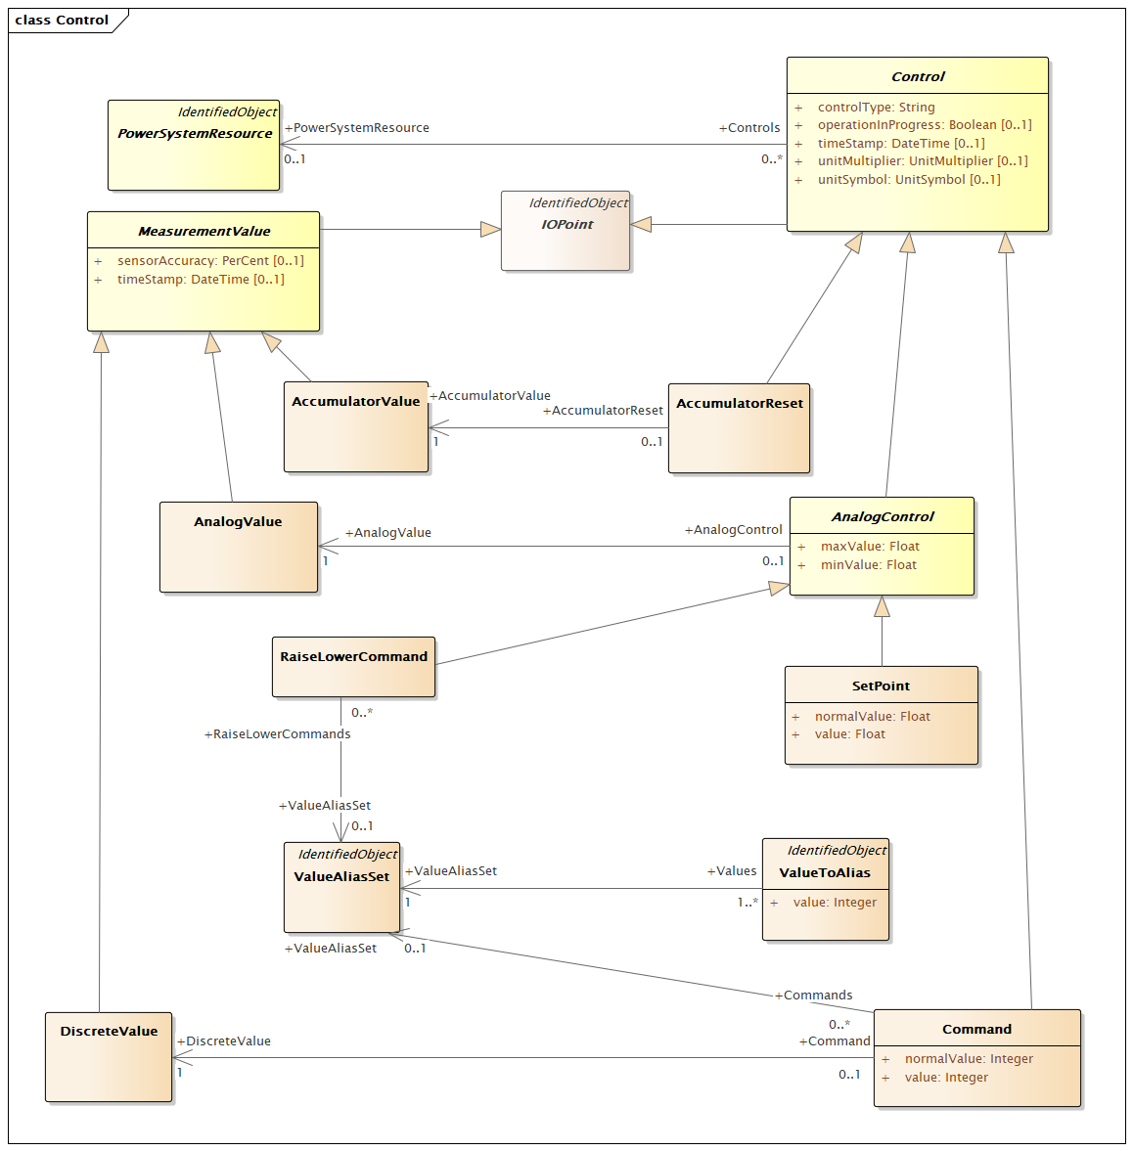

Figure 28 – Class diagram OperationProfile::Control

# Requirement for Change

R1: There must be consistent use of Kind (enumeration) and Type (string) according with the modelling guide and as a minimum in the same inheritance tree.

R2: Need to identify result for addition calculation like:

* Short-Circuit
* Droop
* Inertia

R3: The constrined defined in IEC 61970-452 Table 436 must be able to be address as machine understandable description.

R4: 61970-452 SCADA Reference - Recommended data model exchange attributes should be removed or described in a machine understandable way.

R5: Item in IEC 61970-301 for SCADA should be considered to be added to Operation Profile. As minimum some of the item that in not necessarily unique for SCADA.

R6: Update the model so that the association between CommuncationLink – RemoteUnit is not a 1..n - 0..n (many-to-many).

R7: Need to check with 61850 is the Quality61850 is still valid.

R8: The enumerators Validity and Source should be updated according to modelling guide.

R9: MeasurementValueQuality should be model so that alternative Quality schemes can be used, e.g. Quality61850 becomes a specialisation of MeasurementValueQuality rather than an generalisation.

R10: Existing MeasurementValueSource naming conventions should either become a Kind or specialisation. As it is likely that there could be different association and attributes for the different type of source it might be best to have specialisation.

R11: We have LineToNeutralVoltage, LineToGroundVoltage and Voltage. Is it Voltage that should be used for LineToLineVoltage (Yes).

R12: Should we add 61850 Name for LineToNeutralVoltage and LineToGroundVoltage?

R13: Automatic and LocalOperation does not seem to be Measurement. It is either data about measurement or it is Control.

R14: There is a need to include PetersenCoil measurements like Voltage Resonance, current resonance.

R15: There is a need to clearly distinguish Equipment Temperature, ambient temperature and air temperature.

R16: There is a need to include moisture concentration as a measurement.

R17: Is there a need to state that we have DC Active Power, DC Voltage, DC Current? In principle this is given by the Terminal, but it could be very useful for reporting system to have this implicit.

R18: We are missing the following MeasurementType: AngleDifference, DistanceToFault, GasConcentration (particularly relevant for hydrogen), Inertia, OilTemperature, WindingTemperature, FrequencyDifference, NeutralToGroundCurrent, NeutralToGroundVoltage, OilPressure, ImbalanceCurrent (flow between batteries in a shunt), RotatingSpeed, SF6Pressure and ShortCircuitPower.

R19: The should be a profile that can handle the exchange of Measurement for given measurementValue partners. The value could be exchange as ICCP (or other means), but the reference to all "available" Measurement that can be "subscribed".

R20: Add the possibly to identity where PMU Measurement and the type of measurement that is available.

R21: Need to align the Measurement with the functionality of measure. This need to link to the device that is doing the measurement.

R22: Clarify the meaning of control.controlType.

R23: Add SetActivePower, SetCurrent, SetReactivePower, SetVoltage and SetRateOfChange to Control.controlType if they are not already covered.

R24: Control should not include Control.timeStamp. The timestamp is allocated on the MeasurementValue.

R25: All timeseries value like *.value should not be included in the Operation profile since this is a structure data profile. The system that maintains the structure (master) data might not be the same system that maintain the schedule and real-time data. Having a single value timeseries value might have minimum value.

R26: unitMultipler and unitSymbol might not be valid for all Measurement (e.g. Discrete and StringMeasurement) should consider creating rules or only include these attributes for relevant Measurement.

R27: The use of the Quality61850 must be explain better.