23-Oct-2023 – Joint WG Hybrid Meetings
Monday Meeting Minutes

3:10pm – 4:20pm – CIM Modelling Guidelines Compliance Topics (Chavdar)
Chavdar presented his power point slide deck on the issues that are non-compliant with the CIM Modelling Guidelines.
- Becky: Is there a reason we don’t have these extensions in the normative CIM in the first place
- Svein: The issues the are in the UML presented by Chavdar are attributes specific to the 600-x series for CGMES
- DECISIONS/ACTION ITEMS:
  - Decision 1: We will put more detail into the attribute descriptions (like the approach WG16 has taken between NA and European markets) This does NOT need to happen before the merge next week.
  - Decision 2: All attributes and classes will be brought into normative CIM (an example provided below)
  - Example here is the kind attribute will be moved into the OperationaLimitType (normative) class and a stereotype of <<European>> added to it:

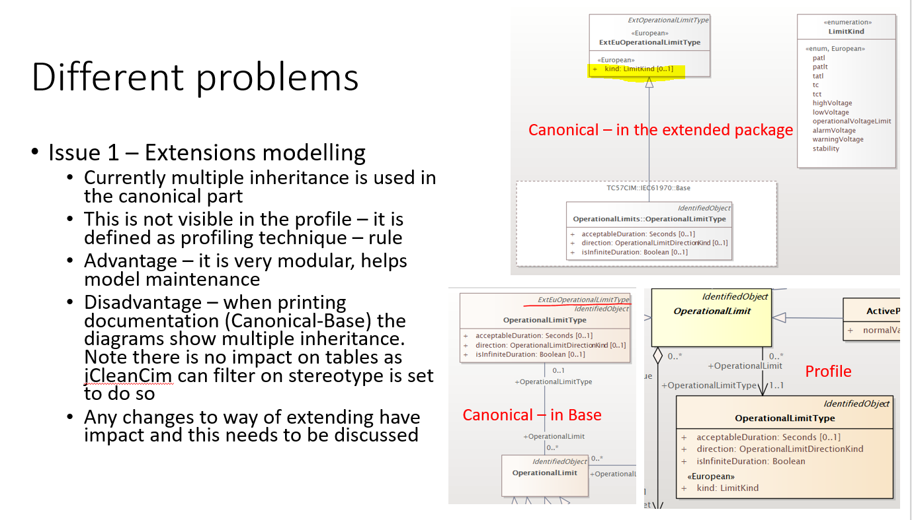
  - Decision 3: We have classes in the Inf* packages that need to be corrected. The issue is that multiple inheritance appears in the UML diagrams generated into the 301/302/457, etc.
    - The decisions / fix for this issue will be as follows: Prior to a 301 document generation the entire Inf* package (top level) is to be deleted (not permanently) before generation. This is applicable to all WGs (WG13, WG14, WG16, WG21)
  - Action Items [Chavdar/Todd]: For the merge we only need to implement Action 2 (above). Therefore, Chavdar will produce a CIM18v08 release that corrects the issues as described here. Todd to create appropriate Redmine Issues and release notes.

