Solution to redmine 6280
sSBOes8 does not check Cancel consistency with SelectWithValue
July 19, 2023
Test case sSBOes8 is checking the consistency of Operate request and SelectWithValue.
sSBOes8 abstract test case states "verify Operate or Cancel" but the detailed test procedure only verifies 'Operate' not the Cancel. Propose to extend sSBOes8 with Cancel part in a similar way as sSBOns8.
To be consistent with sSBOns8 remove the Cancel.Test and Cancel.Check.
Table 108 specifies the expected result to be Cancel resp-. Part 8-1 states the AddCause.
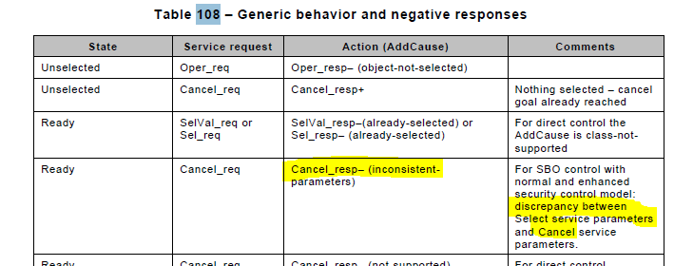

Abstract (no change)
sSBOes8 | Verify that the Operate or Cancel request with different control parameters than the SelectWithValue is rejected with AddCause: Inconsistent-parameters

sSBOes8 | Operate or Cancel with different value then the SelectWithValue of a SBOes control object | Passed  Failed  Inconclusive
IEC 61850-7-2 Table 108
IEC 61850-8-1 Subclause 20.6, 20.7 and 20.8
Expected result
1. DUT responds with SelectWithValue response+
2. DUT responds with Operate response- with AddCause “Inconsistent-parameters”, or only when Operate.test=T with AddCause either “blocked-by-mode" or “Inconsistent-parameters”
3. The control object will return to the unselected state: stSeld=F or SelectWithValue response+ or Operate response‐ with AddCause “object‐not‐selected”
5. DUT responds with SelectWithValue response+
6. DUT responds with Cancel response- with AddCause “Inconsistent-parameters”
7. The control object will return to the unselected state
Test description
- Client sends correct SelectWithValue request of an unselected SBOes object with it’s logical node Beh=on
- Client sends Operate request of the selected object changing one of the following attributes to another value than the SelectWithValue: ctlVal, origin, ctlNum, test and Check
- Wait until control object returns to the “unselected state”, client requests either GetDataValues(stSeld) or SelectWithValue or Operate
- Repeat step 1-3 for the other attributes in step 2
- Client sends valid SelectWithValue request to a control object
- Client sends Cancel with same ControlObjectReference as the SelectWithValue and one of the following attribute values:
- ctlVal = different from SelectWithValue
- origin.orIdent = different from SelectWithValue
- ctlNum = different from SelectWithValue
- T = time from SelectWithValue - 1 minute
- T = time from SelectWithValue + 1 minute
- Wait until control object returns to the “unselected state, client requests either GetDataValues(stSeld) or SelectWithValue or Operate
- Repeat steps 5-7 for origin.orIdent
- Repeat steps 5-7 for ctlNum
- Repeat steps 5-7 for T – 1 minute
- Repeat steps 5-7 for T + 1 minute
Comment

