Modeling behind the inverter
GMDM Issue #9
The GMDM IOP model included a BatteryUnit, PhotovoltaicUnit, and WindPowerElectronicsUnit behind the same residential-sized inverter, i.e., behind a single PowerElectronicsConnection. While theoretically possible, none of the known power flow solvers handle this. PNNL and EPRI both implemented a “virtual battery” concept that might be considered for behind-the-meter or behind-the-inverter resources.
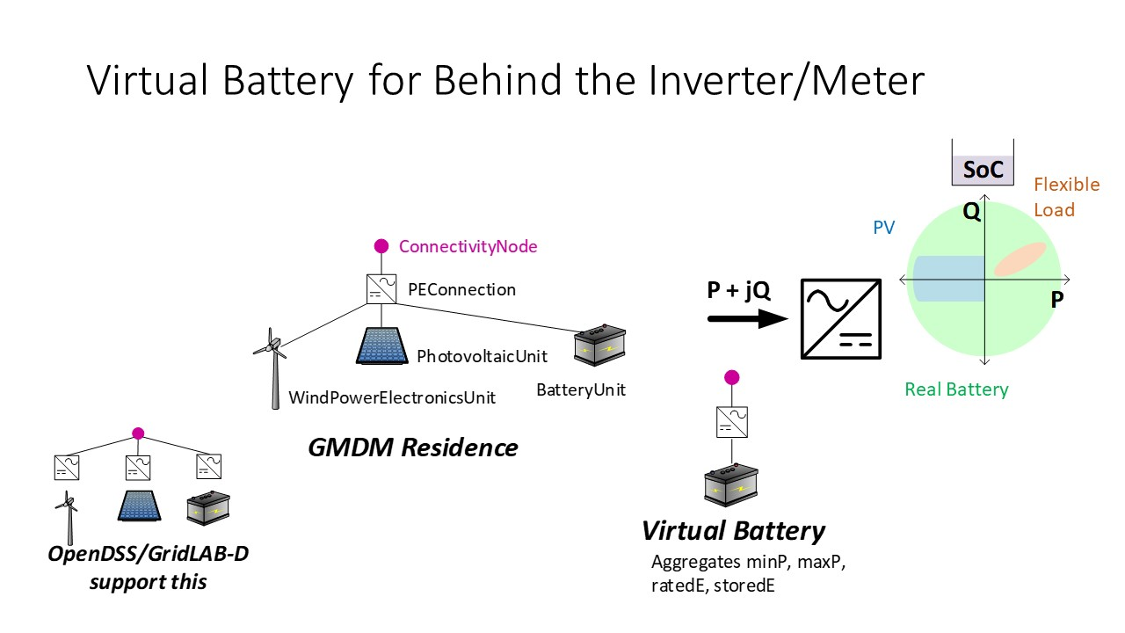
(See also the following references
- https://doi.org/10.1109/PESGM40551.2019.8974107
- https://doi.org/10.1109/JPROC.2020.2986378)

