GMDM IOP Meta Modeling

Meta UML and GMDMMeta profile
The Meta UML used by the GMDM CIM IOP is shown below. It is an attempt to represent the most basic and universal concepts for the organization and management of grid data. It is very simple: it doesn’t, for example, include Change Models, audit trails, or any support for operations or tags. It is intended to allow real world ‘test driving’ of the new -552 serialization approach and to contribute experience to the WG13 conversation currently underway regarding ‘meta data’.

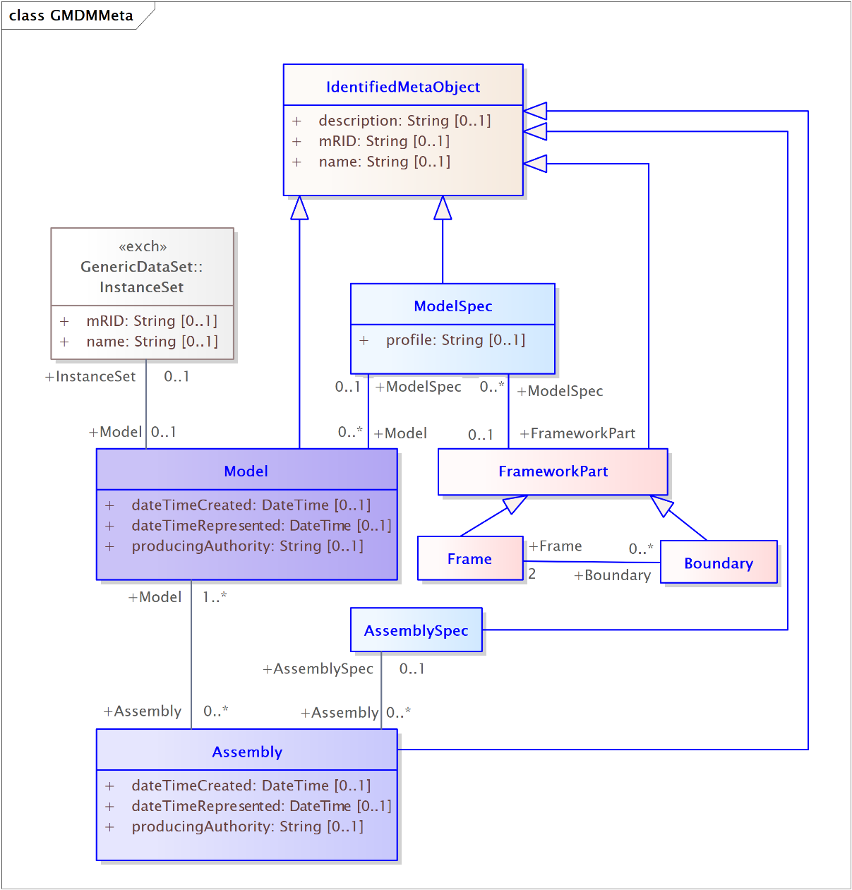

Below is the single Meta profile defined for the GMDM CIM IOP.

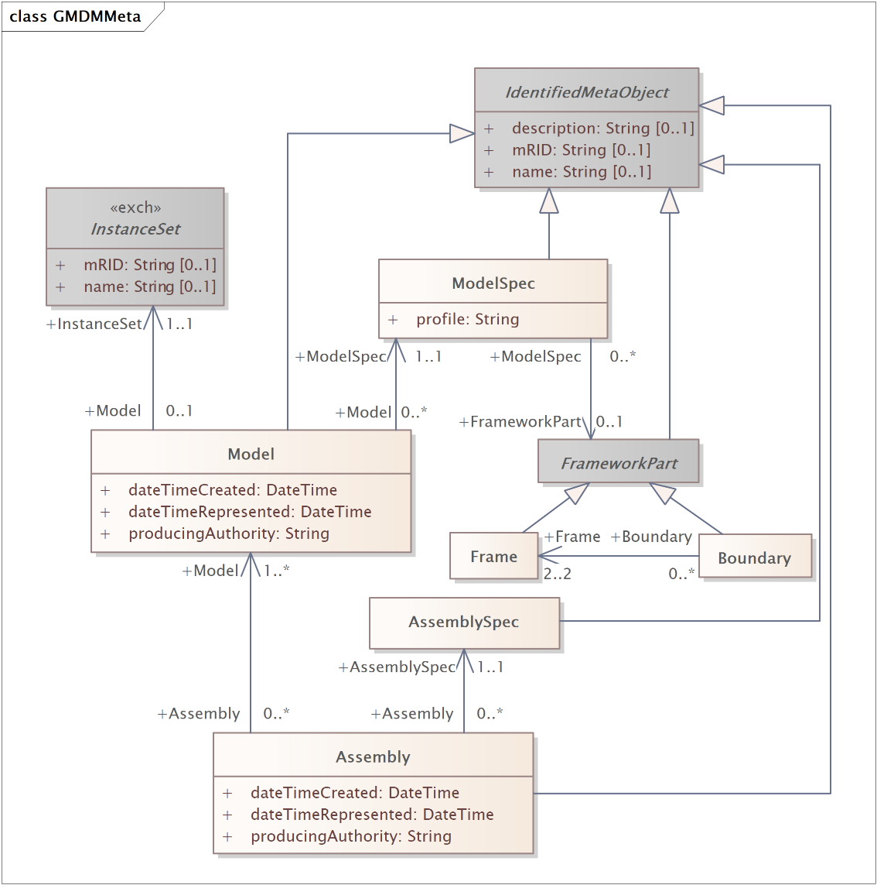

Purpose and lifespan of “Meta” Classes
Instances of the Meta classes have different purposes and lifecycles. To help clarify the use of each of these classes, a description of the persistence of each class has been documented below.

FrameworkPart (Frame / Boundary)
- A FrameworkPart “defines a subset of grid extent.”
- Frame and Boundary instances are created as part of the modelling agreement between modelling authorities and are updated or deleted only by mutual agreement.
- In the GMDM IOP, Frame and Boundary instances will persist for the duration of the IOP and will not be modified.
Model
- A Model is a “representation of electrical characteristics of a portion of the grid at a moment in time.”
- A Model refers to a set of Grid objects, collected together by means of an InstanceSet, which are in a particular state.
- Any change to the Grid objects associated with a Model or to their states implies the creation of a new Model.
- A Model is associated with a single ModelSpec.
ModelSpec
- The ModelSpec class “represents a type of Model or the purpose a set of Models serve.”
- ModelSpec identifies the profile (type of information) contained in a Model as well as the Frame or Boundary the Model “fits into”.
- A ModelSpec instance is created when a purpose for exchange of Models of a certain type is identified and will persist unaltered as long as the purpose exists.
- A ModelSpec allows receiving applications to “understand” the intended purpose of a Model they are sent and to guide processing of the Model. It would be reasonable, for example, to compare the data in two Models, received in sequence, with the same ModelSpec, to identify changes to the Model.
- In the GMDM IOP, the following ModelSpec instances have been defined and will persist unaltered for the duration of the IOP:
ModelSpec | FrameworkPart | GMDMGrid Profile | Type of Model Conforming to ModelSpec
D Fac Golden ModelSpec | D Frame | Facilities | EPRI-created reference Model of feeder comprised of physical grid objects able to be sourced by GIS
T Fac Golden ModelSpec | T Frame | Facilities | EPRI-created reference Model of substation comprised of physical grid objects able to be sourced from engineering design tool
D Fac Vendor ModelSpec | D Frame | Facilities | Esri/Safe-created Model of physical grid objects comprising feeder
T Fac Vendor ModelSpec | T Frame | Facilities | Bentley-created Model of physical grid objects comprising substation
TD Basic Golden ModelSpec | TD Boundary | Basic | EPRI-created reference Model of physical grid objects that fits in TD Boundary [note: this is the only ModelSpec whose Models ‘fit into’ the TD Boundary]
D Ops Basic Golden ModelSpec | D Frame | Basic | EPRI-created complete reference Model of physical grid objects describing feeder [note: ModelSpec purpose is to meet Operations tool needs, but grid objects in these Models are identical to those in D Plan Basic Golden Models]
T Ops Basic Golden ModelSpec | T Frame | Basic | EPRI-created complete reference Model of physical grid object describing substation [note: ModelSpec purpose is to meet Operations tool needs, but grid objects in these Models are identical to those in T Plan Basic Golden Models]
D Plan Basic Golden ModelSpec | D Frame | Basic | EPRI-created complete reference Model of physical grid objects describing feeder [note: ModelSpec purpose is to meet Planning tool needs, but grid objects in these Models are identical to those in D Ops Basic Golden Models]
T Plan Basic Golden ModelSpec | T Frame | Basic | EPRI-created complete reference Model of physical grid objects describing substation [note: ModelSpec purpose is to meet Planning tool needs, but grid objects in these Models are identical to those in T Ops Basic Golden Models]
D Plan SSH Golden ModelSpec | D Frame | SSH | EPRI-created reference Model of situation object attributes for feeder
T Plan SSH Golden ModelSpec | T Frame | SSH | EPRI-created reference Model of situation object attributes for substation

- In the GMDM IOP, the following ModelSpec instances may be created at will by vendors:
ModelSpec | FrameworkPart | GMDMGrid Profile | Type of Model Conforming to ModelSpec
<vendor> Planning Merged ModelSpec | None | BasicAndSSH | Vendor-created merged Model including physical grid objects and situation attributes from D Frame, T Frame and TD Boundary
<vendor> D Basic ModelSpec | D Frame | Basic | Vendor-created complete Model of physical grid objects describing feeder
<vendor> T Basic ModelSpec | T Frame | Basic | Vendor-created complete Model of physical grid objects describing substation

Assembly
- An Assembly is a “collection of Models for a purpose.”
- A new Assembly instance is created every time a collection of models is created and remains unaltered during its lifetime.
AssemblySpec
- The AssemblySpec class “represents a type of Assembly or the purpose a set of Assemblies serve.”
- An AssemblySpec instance is created when a purpose for exchange of a type of collection of Models is identified and will persist unaltered as long as the purpose exists.
- An AssemblySpec allows consuming applications to “understand” the intended purpose of Assemblies they receive and to guide processing of the Assembly.
- In the GMDM IOP, the following AssemblySpec instances have been defined and will persist unaltered for the duration of the IOP:
  - Operations Golden Assembly Spec
  - Planning Golden Assembly Spec
Individual vendors may also create AssemblySpecs of their own for ad hoc data exchanages.
Manifest
- A Manifest provides information about the data included in an exchange. Specifically, a Manifest “identifies the top level InstanceSets (containing Meta objects) contained in a given exchange.”
- A Manifest object is created with each exchange. It is intended to represent one exchange of information.
InstanceSet
- The precise meaning and rules of use for InstanceSet is still under discussion by WG13. There are two views held on the definition of InstanceSet:
  - One is that InstanceSet is strictly a serialization construct, doing nothing more than allowing the ‘packing’ and ‘unpacking’ of data content across multiple .xml files
  - The other is that an InstanceSet is an identifier representing the state of a collection of objects.
- The GMDM IOP use of InstanceSet reflects both:
  - The InstanceSet at the head of an .xml file conforming to the GMDMMeta_Profile is simply a serialization construct and, as such, should be expected to change with every serialization.
  - The InstanceSet at the head of an .xml file conforming to one of the GMDMGrid_xxxx_Profiles is an identifier representing the state of the Grid objects contained in the file. The Grid objects are a ‘property’ of the Model that has an association to the InstanceSet. Under these circumstances, the InstanceSet identifier would persist in parallel with the Model.

