### Starting point for feeder tracing

GMDM Issue #14

The GMDM test model expressed the nominal containership of each ConductingEquipment child in a Feeder by means of the recently created Equipment.EquipmentContainer association with the AdditionalEquipmentContainer role. The decision was made not to use the Feeder.Terminal association for the support of energization training, however. An alternative was implemented which leveraged a proposed Feeder.ConnectivityNode association, specifying a node assumed to always be energized if the feeder was energized.

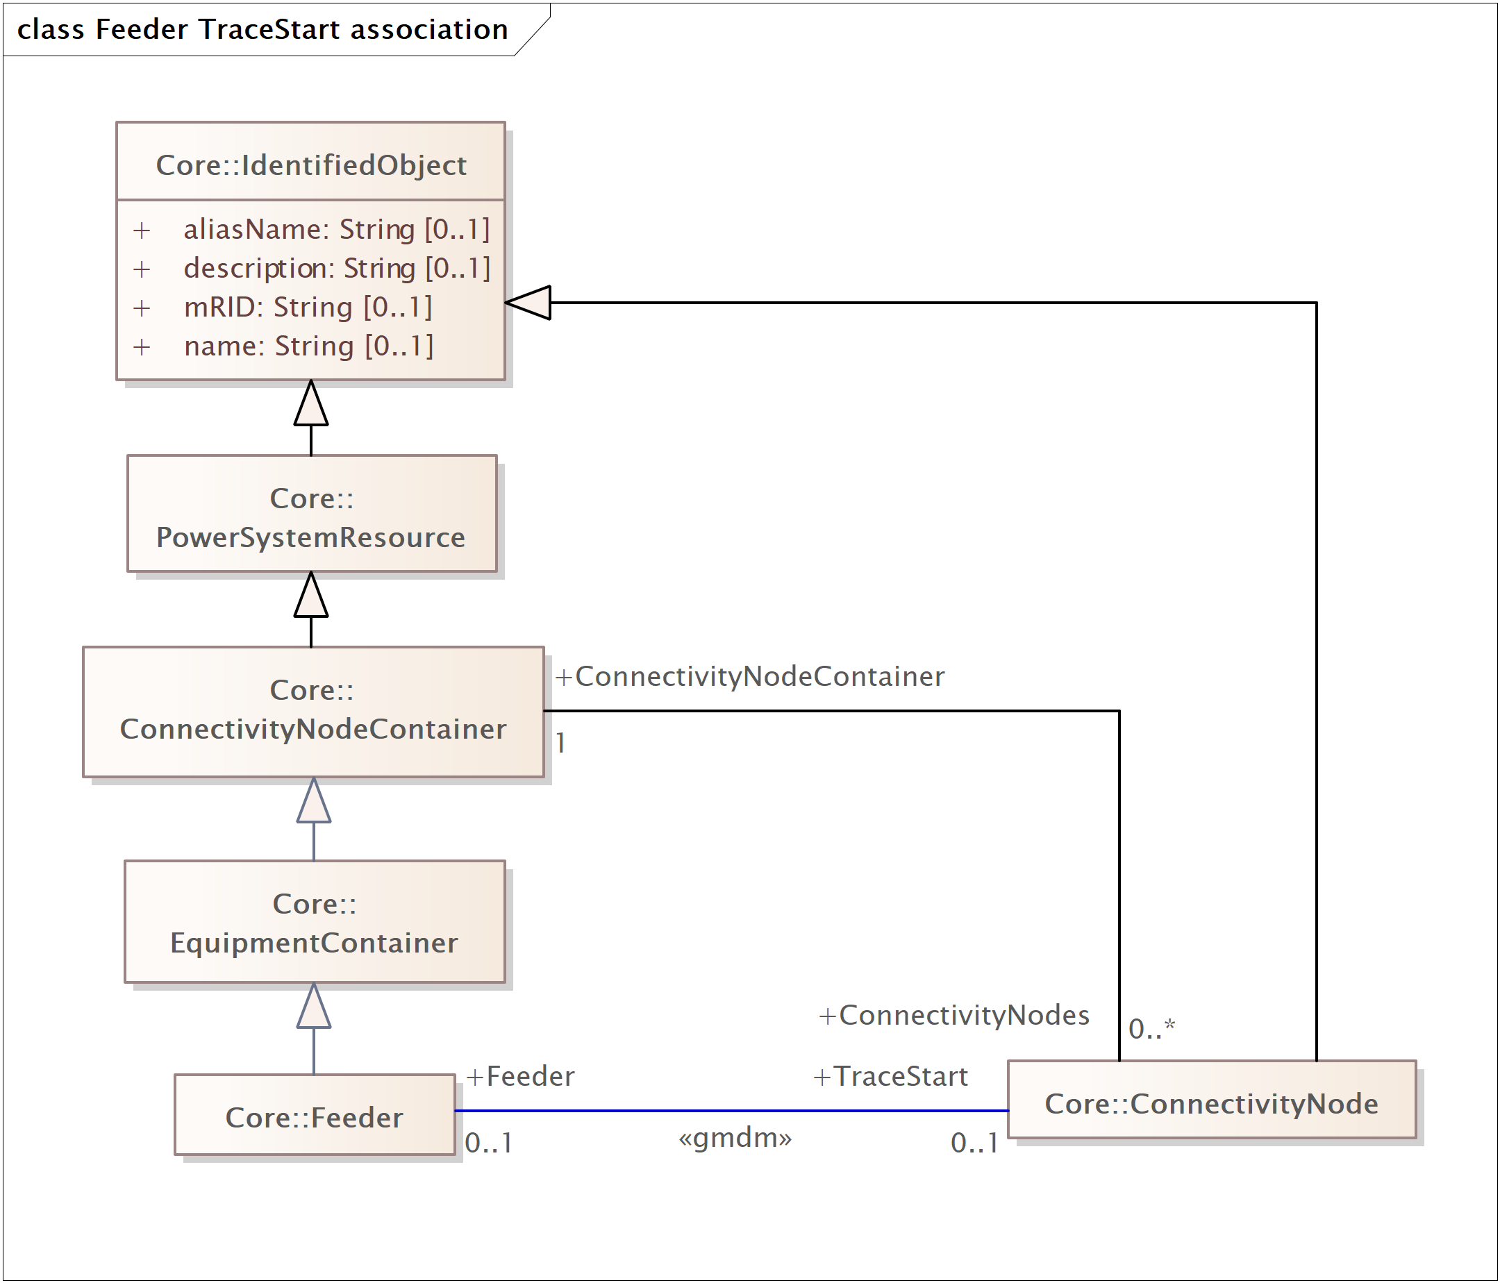

This approach supported more accurate and easier tracing of feeders with two ‘head ends’ (such feeders are typical at Hydro-Québec).

## Discussion of feeder with redundant head ends (by Jay)

Below is an example from HQ showing the head end of the feeder:

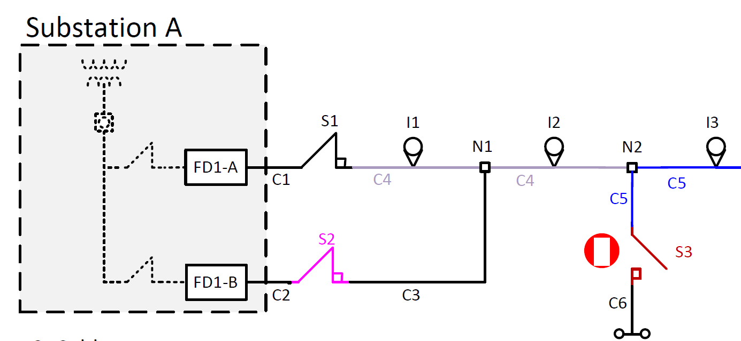

The main feature of this that got me thinking is that the feeder branches into the sub as well as out of the sub. The problem here is that you can’t pick the Terminal of FD1-A as a trace starting point because sometimes S1 is open and S2 is closed. The trace start needs to be a location that is always energized if any of the feeder is energized. There are a few objects electrically centered around node N1 that qualify. However, when the trace start is not at an end point, the trace has to proceed in all directions in order to pick up all the energized components of the feeder. This also means there must be a slightly more complex stop criteria for the trace. Instead of just stopping at open switches, it needs to recognize a closed substation feeder breaker as a stopping point. Bottom line -- the trace start is not a head-end and there is no directionality specification for tracing.

This still leaves open the question as to whether it is better to designate the trace start with a connectivity node or a terminal. While both would work, the connectivity node at N1 is to me the most logical trace start. It is visible to both the substation modelers and the feeder modelers because it is also the logical boundary. The next most logical choice would be the terminal of the line segment between N1 and N2, but this places the trace start definition in the feeder model whereas it was really the substation designers that determined the location. (Here, I am surmising that the substation boundary that is drawn in the figure isn’t quite right. The substation design probably included node N1 rather than having two wires hanging over the substation fence.)

It would be helpful to explore the topic of feeder tracing and the data modeling needed to support it a bit more. Use cases should be run where several types of feeders (simple radial, 2 feeds at one end, 2 individual feeders connected by a normally open switch, etc.) are used as input to several types of functions that need to trace the network (like power flow topology processing, tracing to check model validity, tracing to display current energization status, etc.). Then a proposal for extension/revision could be made.

Resources for the conversation: Martin Bass (ABB), Oracle, Survalent