Phase modeling on the low side of residential and commercial service transformers
GMDM Issue #8
The population of attributes related to transformer windings, and of the related attributes of classes representing loads and distributed generation, posed ongoing challenges during GMDM test model creation.
The power that ‘comes out of’ the low-side transformer end(s) – which is what load and/or distributed generation is connected to - can have phasing that is not the same as what ‘goes into’ the high-side transformer end – which is what higher voltage ConductingEquipment (with xxxPhases) is connected to. There appear to be at least 2 requirements the description of low-side load/generation phasing needs to support: an accurate electrical representation for power flow (where characteristics of the feeding transformer are taken into account) and a ‘short hand’ that identifies the effect of high-side phase outages on low-side load/generation. A suggestion was made to add a .primaryPhase attribute on the EnergyConsumerPhase and PowerElectronicsConnectionPhase classes. Further exploration is needed.
Another area of difficulty related to the accurate description of phasing on load and distributed generation using the existing class attributes. The EnergyConsumer and EnergyConsumerPhase classes represent load and have the following phasing-related attributes:
- EnergyConsumer.grounded (true/false)
- EnergyConsumer.phaseConnection (with a datatype of PhaseShuntConnectionKind with possible values of D, Y, Yn, I and G)
- EnergyConsumerPhase.phase (with a datatype of SinglePhaseKind with possible values of A, B, C, N, s1, s2)
The PowerElectronicsConnection and PowerElectronicsConnectionPhase classes represent load and distributed generation and have the following phasing-related attributes:
- PowerElectronicsConnection.ratedU
- PowerElectronicsConnectionPhase.phase (datatype of SinglePhaseKind)
Shortcomings/challenges identified during GMDM IOP modeling effort included:
- For load modeling, the inability to explicitly represent 240 load made up of s1 and s2. Expanding the list of enumerated values of the SinglePhaseKind datatype was suggested as possible solution, as was replacing the EnergyConsumerPhases.phase and PowerElectronicsConnectionPhase.phase attributes with .orderedPhases attributes (datatype OrderedPhaseCodeKind with 50+ possible values). (The TransformerTankEnd.orderedPhases attribute uses OrderedPhaseCodeKind.)
- Difficulty in determining the appropriate values of EnergyConsumer.phaseConnection (datatype PhaseShuntConnectionKind with possible values of D, Y, Yn, I, G) and EnergyConsumer.grounded to accurately characterize the load while also aligning with TransformerEndInfo.connectionKind (datatype WindingConnection with possible values on D, Y, Z,Yb, Zn, A and I) and TransformerEnd.grounded. The notes (description) of the .grounded attributes in UML require review as well.
- The lack of PowerElectronicsConnection.phaseConnection and PowerElectronicsConnection.grounded attributes which are present on the EnergyConsumer class. There seemed to be a consensus that they should be added.
- Disagreement relative to the value that should be assigned to .ratedU on a single-phase inverter (0.12 vs 0.24) object (instance of PowerElectronicsConnection class).
(See the associated file called Bubble Diagram GMDMGrid_BasicAndSSH.vsdx, specifically the following portions on the D Model tab:
- Classes related to PowerTransformer with .name=Xf1 (individual residential service transformer), including all Switch, EnergyConsumer and PowerElectronics-related classes
- Classes related to PowerTransformers with .name=Xf6a, Xf6b, Xf6c (residential service transformer with aggregated customer load modeling), including all their EnergyConsumer-related classes
- Classes related to PowerTransformer with .name=Xf2 (box store transformer), including its related EnergyConsumer class
- Classes related to PowerTransformer with .name=Xf4 (convenience store transformer), including its related Switch and EnergyConsumer-related classes)
Also see Peppanen, Rocha, Taylor, and Dugan, “Secondary Low-Voltage Circuit Models – How Good is Good Enough?”, https://doi.org/10.1109/TIA.2017.2764024. Figure 6 of the paper shows a detailed transformer model with s1 and s2 phasing on the secondary. Figure 7 shows a simplified transformer model with A, B, or C phasing on the secondary; it’s good enough for balanced secondary loads and 15-minute data. For analyzing secondary loads or faster data streams, Figure 6 is applicable.
Also, this excerpt from a presentation by Tom McDermott:
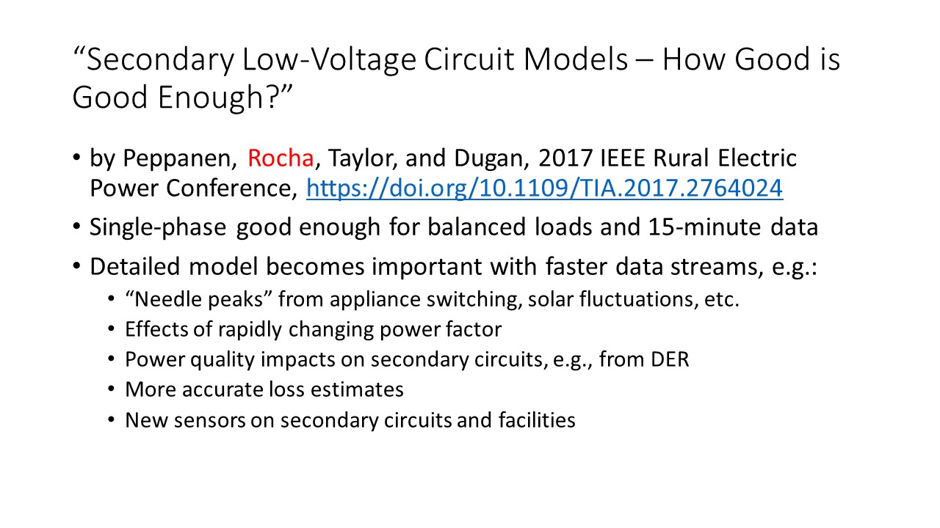
https://doi.org/10.1109/TIA.2017.2764024

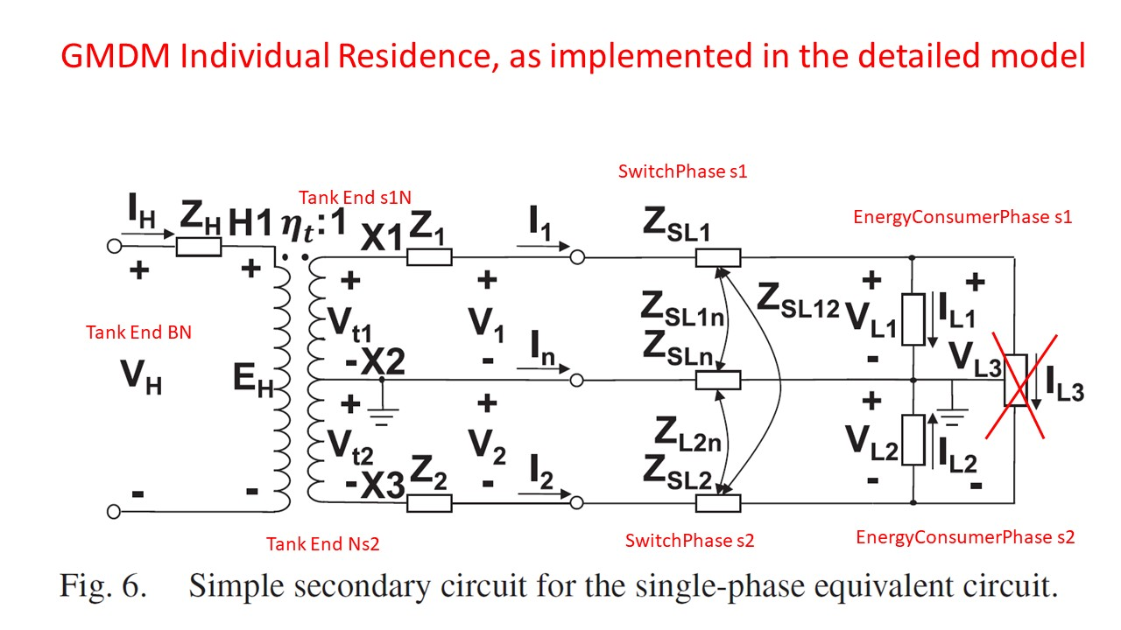
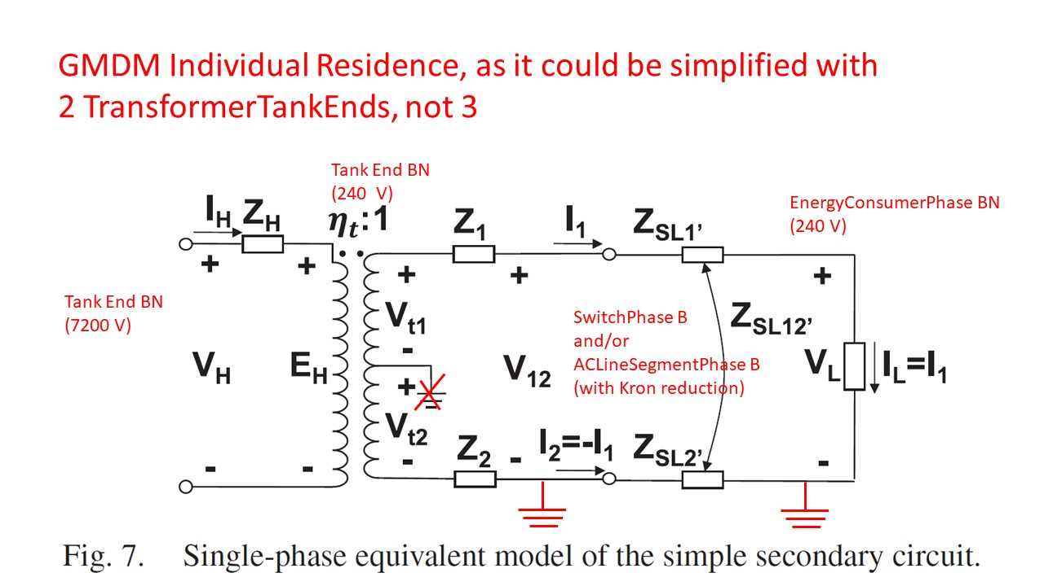

As was suggested for transformer modeling, the provision of examples of ‘best practice’ modeling for typical load and distributed generation installations would greatly improve the ease of implementing CIM data exchanges. Consideration should be given to various use cases for the modeling of consumer load: some studies may be interested in the distinction between customer 240 load and the 120 load (or even the 120 load on either split), other studies will want all 240 and 120 load supplied by a transformer aggregated into a single load. The examples should reflect both the type of transformer from which the load/generation is fed and the type(s) of studies for which they are appropriate. This guidance belongs in some sort of ‘how to use the CIM’ document.
Additional resources for the conversation: Jun Zhu, Martin Bass (ABB), Survalent, Oracle, EPRI, Tom McDermott

