Streamlining of tank-based transformer modelling
GMDM Issue #1
Currently, the modelling of an unbalanced (tank-based) transformer can be accomplished in a variety of ways, using a multitude of combinations of classes and associations. The number of possible alternatives is an impediment to interoperability. A number of the classes used in describing transformers for network modelling purposes are also resident in the 61968 package, not the 61970 package, despite the fact that they were designed to support network analysis, not asset management, use cases.
This issue suggests the articulation of a comprehensive, cohesive approach to tank-based transformer modelling which would accomplish the following:
- Support the modelling of tank-based transformers in strictly electrical terms
- Support the modelling of tank-based transformers using test results
- Support the definition of ‘catalog’ information of both kinds of modelling (electrical terms and test results)
- Align with the current balanced (non-tank-based) transformer modelling described by 61970-301 and -452
- Augment the current non-tank-based modelling to allow modelling of those transformers with test results
The net outcome is anticipated to significantly leverage existing classes, attributes and associations. Likely changes include a few new associations that clarify (and support validation of) intended usage, perhaps some moving of attributes from one class to another and the move of a number of classes from the 61968 package to the 61970 package.

Additional information on a few of the issues with the current modelling:
- The use of TransformerMeshImpedance and TransformerCoreAdmittance to express transformer impedances in unbalanced network models also requires TransformerEndInfo objects and, in the most rational approach, also a TransformerTankInfo object. The need for the xxxInfo classes is because some of the required attributes are not defined in the TransformerTankEnd class – they exist only in the TransformerEndInfo class. Interestingly, the information model has a PowerTransformerEnd class (a ‘sibling’ of the TransformerTankEnd class) that has the required attributes.
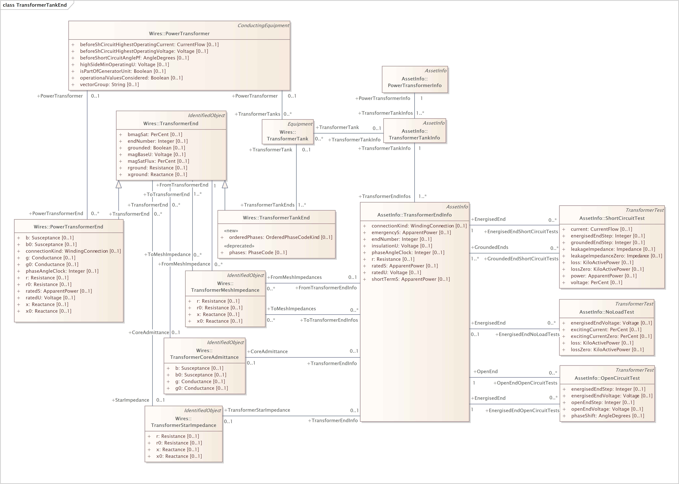

- The 3 transformer test results classes (ShortCircuitTest, NoLoadTest, OpenCircuitTest) are currently used by distribution network analysis tools as input to transformer impedance derivation functions. They are often used as ‘catalog’ information, describing the characteristics of multiple transfomers. While use cases have not yet been explored to understand the completeness of the test results classes to support impedance calculations for balanced transmission models, it is likely that the provided information would come close to satisfying requirements for that purpose, too.
Despite the fact that the test results classes appear in the 61968 package, they are tailored for these impedance derivation functions and do not reflect the typical ‘procedure results’ modelling done in WG14 which uses ProcedureDataSet. ProcedureDataSet (and the related Procedure class) are intended to express the results of a variety of types of procedures that can be done on assets. There are messages defined for the use of the Procedure and ProcedureDataSet classes in 61968-4, but use cases fleshing out their requirements are limited. It is likely that no use cases for transformer test results have been analysed.
While there is overlap between the transformer test results data required for network analysis and what would probably be described by a ProcedureDataSet instance for asset purposes, there are significant differences:
- network analysis needs are a subset of the asset needs and would not come close to satisfying a complete set of asset management transformer test results requirements
- the ProcedureDataSet structure is complex and flexible to meet the varied needs of expressing the results of all sorts of procedures for asset maintenance purposes, but it is unduly complicated for tools doing impedance calculation. (to ‘find’ the value of a test result attribute – say leakage impedance – one would need to find the Measurement associated with the Procedure describing the transformer test and then navigate to the MeasurementValue of the most recent (or applicable) version of the ProcedureDataSet.)
It seems reasonable to move the transformer test results classes to 61970.

- A related issue is the definition of asset or asset tank datasheets. But it is out-of-scope for this issue and should be addressed with a separate issue – a joint one between WG13 and WG14. Currently 61968 defines PowerTransformerInfo and TransformerTankInfo classes which inherit from AssetInfo, but they have no attributes and serve only as classes for defining assemblies of TransformerEndInfo classes (The TransformerEndInfo class does have select datasheet information, but it is also the same sort of information as is described on the 61970 PowerTransformerEnd class.)

