Solution to redmine 6192
Tissue 1730 Resolution

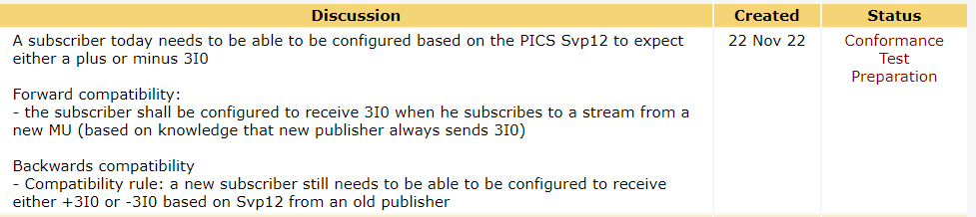

sSvp8 | Verify plausibility that the sampled values match with the analogue signals and quality | Passed  Failed  Inconclusive
IEC 61869-9 Clause 6.903.9
PIXIT: Svp5, Svp12
Expected result
3. Voltages
- If VN is calculated, check that VN is equal to the magnitude of VA, VB, VC when applying 1 phase voltage and near zero when no signal is applied.
- For measured channels, verify match with signal source
Currents
- If IN is calculated, check that IN is equal to the magnitude of IA, IB, IC (verifying the sign) when applying 1 phase current and near zero when no signal is applied.
- For measured channels, verify match with signal source (verifying the sign) when applying 1 phase current and near zero when no signal is applied
Quality
- The validity is good when the signal is measured or calculated
- The overflow, badReference, oscillatory, oldData, inconsistent and operatorBlocked flags shall be set to false
- The source shall be process
- For backward compatible MSVCB it is permissible to set the “derived” bit (bit 13) when the value is calculated
Test description
1. Configure the DUT with the highest rate backwards compatible configuration and the correct parameters and frequency
2. Apply current and/or voltage signals to each phase 1 at-a-time for at least 5 seconds each then apply no signal for 10 seconds
3. Capture the sampled values messages

Comment
This is a plausibility check not an accuracy test.
Tested with configuration: X

Svp12  (depreated) | Calculated IN  = (Ia, Ib, Ic).  = -(Ia, Ib, Ic) | Y  N

- 7 | Verify that the polarity of the subscribed IN can be configured (backward compatibility – compatibility rule)

sSvs17 | Verify that the polarity of the subscribed IN can be configured (backward compatibility – compatibility rule) | Passed  Failed  Inconclusive
IEC 61869-9
Tissue 1730,
PIXIT Svs12
Expected result
1-2. DUT subscribes to the sampled values. In values have interpreted an -(Ia, Ib, Ic) according to PIXIT.
Test description
Configure DUT to subscribe to a random SV stream with a recommended destination MAC address
Verify that the configuration allows to interpret the In as –(Ia, Ib, Ic).
1. SIMULATOR publishes SV stream
2. Apply current signals to each phase 1 at-a-time for at least 5 seconds each then apply no signal for 10 seconds – published In as –(Ia, Ib, Ic).
Comment
Tested with configuration: X and Y

Svs12 | Which function can be used to verify the polarity of subscribed samples In?

