UCA IOP 2022 Problem Report Sheet
Reporting Person: |  | Benson Chacko
Check the CheckBox most appropriate test area(s) concerning the reported issue:
Test Area | ☒SCL |  | ☐Client/Server | ☐ GOOSE | ☐SV
 | ☒R-GOOSE |  | ☐Security | ☐PRP/HSR | ☐TimeSync
 | ☐Maintenance /  Isolation |  | ☐Infrastructure
Check the CheckBox regarding the general classification of the issue:
Type of issue: | ☐Test Case |  | ☐Standard | ☒General | ☐Unknown
Problem Statement (type into the following cell):
From the iec61850-6 standard, there is no attribute to define maximum no of R-GOOSE publishers supported.
R-GOOSE capability need not be same as NORM GOOSE. As R-GOOSE might be used only for inter substation communication

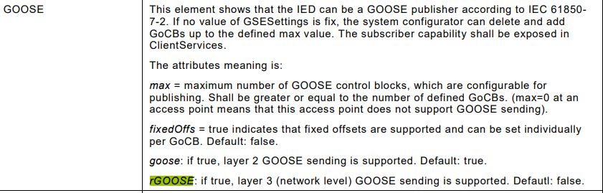

To be filled out during Group Problem Review:
Check the CheckBox most appropriate problem category:
Problem with: | ☐Implementation | ☒Standards |  | ☐ TestCase | ☐Interpretation
 | ☐Other
Check the CheckBox regarding the general classification of the issue:
Solution | ☐Refer to Standards |  | ☐See Below
Proposed Solution (type into the following cell):
Believe there should be a differentiation in the service section between GOOSE and R-GOOSE support.
Should refer to UFTF.
Note that the file needs to be named: <DateTime>._<Test Area>_<Witness>_<Test Case>.docx.
<DateTime> should be of format 202207ddhhmm (hhmm in 24 hour time).
Upload filled out document into: [UCAIug Box]/IEC61850 IOP/..Restricted Information/Problem Reports/reported
(https://app.box.com/folder/166086762694)

