Solution to redmine 5961
sCtl16 add LocSta to match table B.1
October 18, 2022
Comment Thierry:
1) If LocSta is not present then the device does not make a difference between remote and station operation. LocSta has been introduced to enhance the switching hierarchy by differentiating operations originated in the station from operations originated in the control center.
2) There is no default value for LocSta - if it is not present, operation from station and remote are treated the same - with regard to the Loc switching hierarchy.
3) Ct29 is needed, because usage of 1 (bay-control), 4 (automatic-bay) can be verified and limited by the implementaton: Local HMI (1) is done locally not over communication, Automatic bay (4) - Logic is done locally not over communication.
When XCBR/XSWI.Loc is true, then even CSWI can not operate the switching equipment. Since sCtl16 is using CSWI for switching operation, then sCtl16 can only be performed with XCBR/XSWI.Loc = false

Richard:
some devices have LocSta others don’t. We better clarify that if LocSta is present it shall be F, so at SBOes step 3 with orCat=3 the SelectWithValue shall succeed.

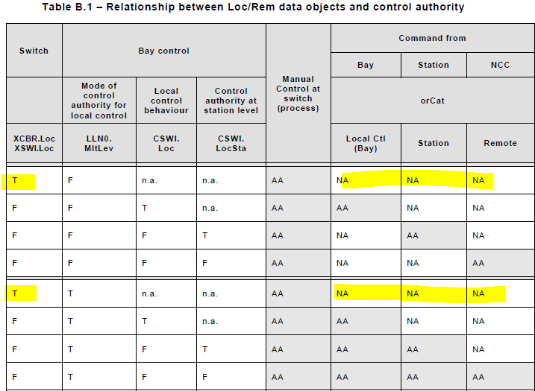
For the last steps XCBR/XSWI.Loc=False while CSWI.Loc=T; orCat Bay = allowed.
PIXIT we keep Ct29 as is
Ct29 | Amd1 | Does the IED support XCBR/XSWI.Loc=False and LLN0/CSWI.Loc=True  When yes, does the IED accept the control when orCat=1 or 4 Local | DOns: Y/N, orCat 1-4: Y/N  SBOns: Y/N, orCat 1-4: Y/N  DOes: Y/N, orCat 1-4: Y/N  SBOes: Y/N, orCat 1-4: Y/N

Updated sCtl16:

sCtl16 | Control an object when the IED is in Local operation | Passed  Failed  Inconclusive
IEC 61850-7-2 Subclause 20.5.2.6, Table 54
IEC 61850-7-4 Table B.1
IEC 61850-8-1 Subclause 20.6, 20.7 and 20.8
PIXIT: Ct13, Ct20, Ct21, Ct29
Expected result
a) DOns
1,3 DUT sends Operate response- with optional AddCause “Blocked-by-switching-hierarchy” or “Not-supported”
2. DUT behaves according to the PIXIT
b) SBOns
1,7. DUT sends Select response- or Operate response- with optional AddCause “Blocked-by-switching-
hierarchy” or “Not-supported”
3. DUT sends Select response+
5. DUT sends Operate response- with optional AddCause “Blocked-by-switching-hierarchy” or
“Object-not-selected”
6. DUT behaves according to the PIXIT
c) DOes
1,3. DUT sends Operate response- with AddCause “Blocked-by-switching-hierarchy” or “Not-supported”
2. DUT behaves according to the PIXIT
d) SBOes
1,7. DUT sends SelectWithValue or Operate response- with AddCause “Blocked-by-switching-
hierarchy” or “Not-supported”
3. DUT sends SelectWithValue response+
5. DUT sends Operate response- with AddCause “Blocked-by-switching-hierarchy” or
“Object-not-selected”
6. DUT behaves according to the PIXIT
Test description
Test engineer changes the DUT to “Local”; (LLN0.Loc=True or CSWI.Loc=True) and XCBR/XSWI.Loc=True if supported and LocSta=False if supported

- DOns
1. Client sends multiple Operate request with following values of orCat = 1, 2, 3, 4, 5, 6
When supported change XCBR/XSWI.Loc from True to False, keep LLN0/CSWI.Loc=True and perform steps 2,3
2. The matching client sends Operate request with orCat = 1, 4
3. The matching client sends Operate request with orCat = 2, 3, 5, 6
- SBOns
- Client sends multiple Select request, on respond+ Client sends Operate with following values of orCat = 1, repeat for orCat = 2, 3, 4, 5, 6
- Test engineer sets the local/remote switch on the DUT to “Remote”
- Client sends Select request
- Test engineer sets the local/remote switch on the DUT to “Local”
- Client sends Operate request with orCat=2 within the select timeout
When supported change XCBR/XSWI.Loc from True to False, keep LLN0/CSWI.Loc=True and perform steps 6,7
- Repeat step 1 with orCat = 1, 4 with a matching client
- Repeat step 1 with orCat = 2, 3, 5, 6 with a matching client
- DOes
1. Client sends multiple Operate request with following values of orCat = 1, 2, 3, 4, 5, 6
When supported change XCBR/XSWI.Loc from True to False, keep LLN0/CSWI.Loc=True and perform steps 2,3
2. The matching client sends Operate request with orCat = 1, 4
3. The matching client sends Operate request with orCat = 2, 3, 5, 6
- SBOes
- Client sends multiple SelectWithValue request, on respond+ Client sends Operate with orCat=1, repeat for orCat = 2,3,4,5,6
- Test engineer sets the local/remote switch on the DUT to “Remote”
- Client sends SelectWithValue request with orCat=3
- Test engineer sets the local/remote switch on the DUT to “Local”
- Client sends Operate request with orCat=3 within the select timeout
When supported change XCBR/XSWI.Loc from True to False, keep LLN0/CSWI.Loc=True and perform steps 6,7
- Repeat step 1 with orCat = 1, 4 with a matching client
7. Repeat step 1 with orCat = 2, 3, 5, 6 with a matching client
Comment
Note: “matching” client means a client that is allowed by the server to issue control

