TapChanger and TapChangerInfo .ctRating, .ctRatio and .ptRatio attributes
GMDM Issue #2
For the GMDM IOP, 3 attributes were copied from TapChangerInfo to TapChanger: .ctRating, .ctRatio and .ptRatio. This obviated the need to include TapChangerInfo objects in the GMDM profiles and data exchanges.
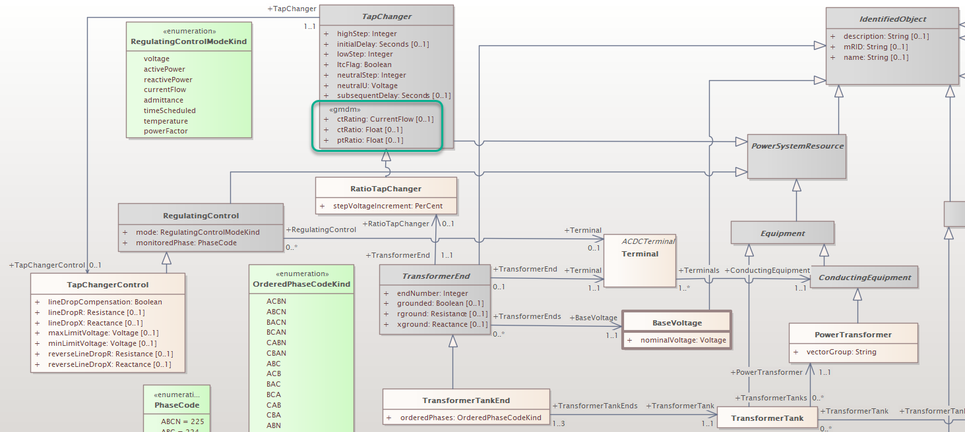
The value of permanently adding those attributes to TapChanger should be explored. As above, the conversation should take place within the larger context of addressing the need to support ‘electric parameter only’ distribution grid model data exchange.

