UCA IOP 2022 Problem Report Sheet
Reporting Person: |  | Chris Dyer
Check the CheckBox most appropriate test area(s) concerning the reported issue:
Test Area | ☒SCL |  | ☐Client/Server | ☐ GOOSE | ☐SV
 | ☐R-GOOSE |  | ☐Security | ☐PRP/HSR | ☐TimeSync
 | ☐Maintenance /  Isolation |  | ☐Infrastructure
Check the CheckBox regarding the general classification of the issue:
Type of issue: | ☐Test Case |  | ☐Standard | ☒General | ☐Unknown
Problem Statement (type into the following cell):
ICD cannot be imported into SCT without errors:
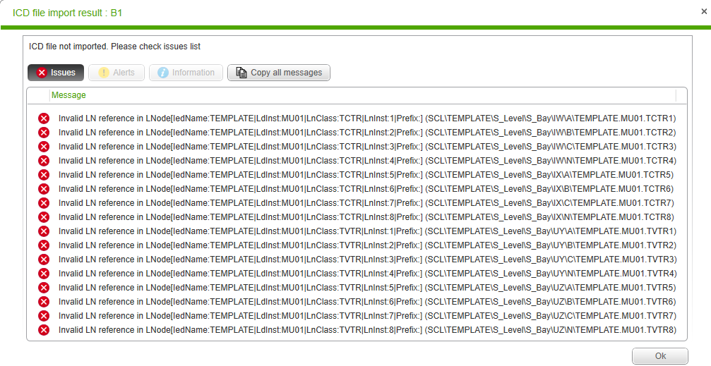
The ICD file is not defining properly the LNode as per Part 6 ed 2.1 §9.2.6 definition:

In this ICD, the TCTR/TVTR LNs in the IED have all a prefix which is not used in LNode:

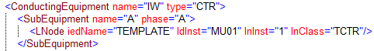

This misconfiguration has not been seen by any validation tool.

To be filled out during Group Problem Review:
Check the CheckBox most appropriate problem category:
Problem with: | ☒Implementation | ☐Standards |  | ☐ TestCase | ☒Interpretation
 | ☐Other
Check the CheckBox regarding the general classification of the issue:
Solution | ☒Refer to Standards |  | ☐See Below
Proposed Solution (type into the following cell):
ICD must specify the correct LN reference if instantiating a Substation section.

A question is how can a ICD provide the Substation section and is the SCT imports the ICD. What is the requirement on the SCT? The SCT is not required to utilize the ICD provided Substation section.

What should an SCT do upon import of an ICD/IID that has a substation section. Refer to UFTF. Suggest that ICD Substation section is a suggestion and can be ignored. An IID with a substation section should be validated that it has not been changed as the SCT is responsible for this.
Note that the file needs to be named: <DateTime>._<Test Area>_<Witness>_<Test Case>.docx.
<DateTime> should be of format 202207ddhhmm (hhmm in 24 hour time).
Upload filled out document into: [UCAIug Box]/IEC61850 IOP/..Restricted Information/Problem Reports/reported
(https://app.box.com/folder/166086762694)

