UCAIug IEC 61850 Vendor and Test Lab Submission Requirements for Conformance

Revision History:

Date | Revision | Who | Changes

Table of Contents
1 Introduction 4
2 Vendor Supplied Information 8
2.1 Company Name (Mandatory) 8
2.2 Company Address (Mandatory) 8
2.3 Company Contact and Phone Number (Mandatory) 8
2.4 Product Name (Mandatory) 8
2.5 Short Description (Mandatory) 8
2.6 Long Description 8
2.7 Hardware Version (mandatory) 8
2.8 Software Version (mandatory) 9
2.9 61850 Edition 9
2.10 61850 Aspects to Be Tested 9
2.11 Keywords 9
2.12 Test Procedure Required Vendor Information 11
3 Required information Test Laboratory to Certification Body 11
4 Certification Body Usage of Information 11
5 Vendor costs for posting of the certificate 12

Introduction

This document provides the detailed requirements for requesting IEC 61850 implementations be tested for conformance. This document specifies:

- The process to be followed.
- The required information to be provided by the vendor whose implementation is to undergo testing.
- The requirements of the Test Laboratory submission to the UCAIug CB for certificate certification and posting.
- The vendor requirements for having a certified conformance certificate posted.

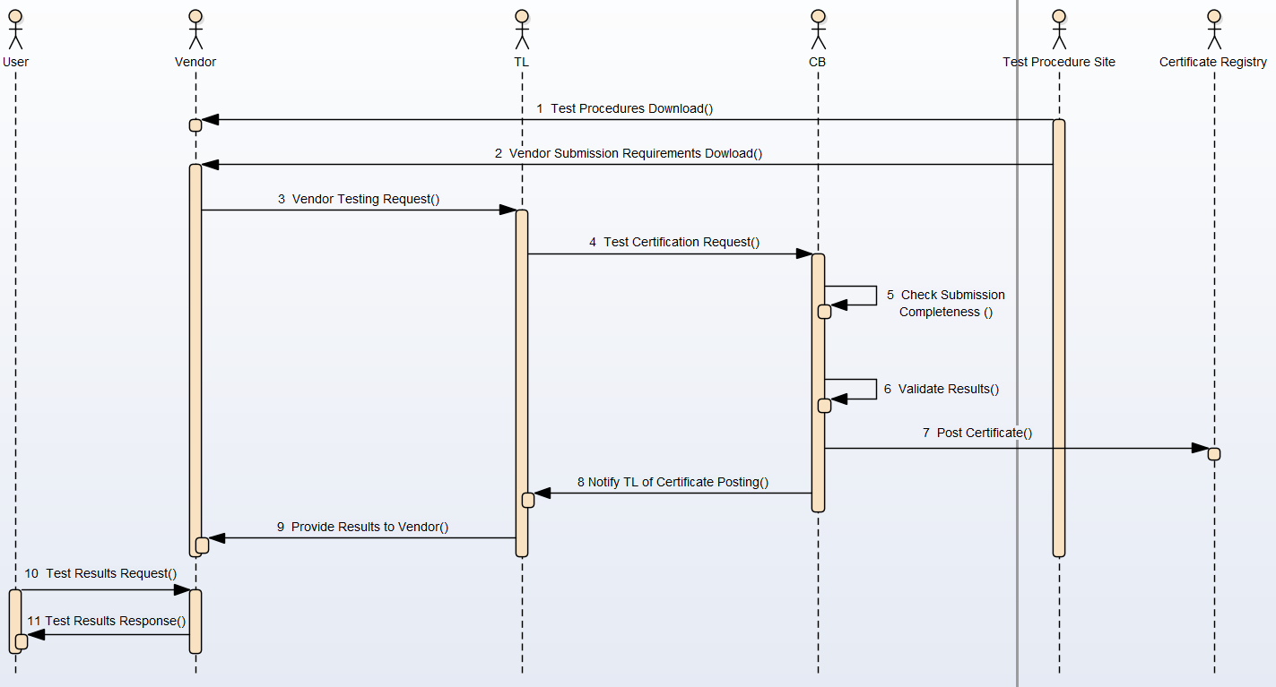Figure 1: Submission Sequence

Figure 1 depicts the expected sequence of information submission and exchange for conformance testing and certificate certification by the CB. There are several parties that are stakeholders in this process:
- Vendor: This is the stakeholder that is submitting an implementation to the TL for conformance testing and wishes to have a conformance certificate certified by the CB.
- Test Lab (TL): This is the stakeholder that the Vendor has selected to perform the conformance tests.
- Certification Body (CB): Is responsible stakeholder for analyzing the results and documentation provided by the TL to evaluate if the certificate appropriate represents the results of the conformance tests.
- User: Is a stakeholder who has an interest in the results of the conformance test and potentially the actual test results and device information so they can evaluate utilizing the tested implementation in a deployment.
There are several primary objectives of the sequence:
- Elimination of guesswork by the TL or CB in regard to what the information related to the implementation submitted for testing.
- Provide traceability of information provided by the vendor and produced by the TL which is submitted to the CB.
- Provide a traceable mechanism for the User to obtain information, and the certificate, that allows trust the authentication of the information.

The sequence shown in Figure 1 consists of the following steps:
- The vendor prepares for submitting their implementation for testing. If the vendor is a UCAIug member, they may decide to download the conformance test procedure(s) that their implementation is desired to be tested against.
- The vendor will need to obtain the information that they will be required to submit in order to undergo conformance testing. Each UCAIug TPWG is responsible for developing this information and posting the document for their specific conformance testing so that the vendor can download the information.
A common requirement shall be an agreement that the TL may share the provided information, test results, and other supporting materials with the CB to allow certificate certification.
- The vendor prepares the set of required information and submits a conformance testing request, including the required materials, to an accredited TL of their choice.
If the required information is not provided, the TL shall NOT begin conformance testing and shall inform the vendor of what information is missing.
Once the required information is received by the TL, the TL will perform the conformance test(s).
- If the implementation under test passes conformance tests, the TL will generate a certificate for certification by the CB. A formal request to the CB via email, for certificate certification shall be provided via email to the CB entity responsible for certificate review.
This formal request shall include the following:
  - A PDF version of the certificate that is to be certified.
  - A SHA-256 hash of the PDF certificate file. This is required for traceability and authentication purposes in order to detect any potential tampering.
  - A *.zip file that includes the information that the vendor submitted, test results, and other information specified by the relevant TPWG. The *.zip file shall be uniquely named and it is highly recommended that it be named to be able to be correlated with the submitted certificate name.
  - A SHA-256 hash of the *.zip. This is required for traceability and authentication purposes in order to detect any potential tampering.
- If there is no formal request, or if any of the required submission is missing, the CB shall NOT start the certificate review process.
- If the submission is complete, the CB shall evaluate the certificate that it properly reflects the test information provided. This shall be a spot check since the TL is accredited.
- If the certificate contents are validated, the CB shall post the certificate to a public site along with its TL provided SHA-256 hash. Additionally, the name of the *.zip shall be posted along with its SHA-256 hash.
- Once the CB posts the information, it shall delete the *.zip and inform the TL that the certificate was accepted or rejected. This notification shall be performed via email.
- If the certificate was accepted by the CB, the TL will provide the certificate, *.zip, and the SHA-256 hash(s) to the vendor.
It is the responsibility of the vendor to archive the *.zip so that a user may request the testing information from the vendor.
- A user may request the vendor for test result information related to a specific test certificate. The vendor is not required to provide this information. But should the vendor decide to fulfill the request, the *.zip should be provided. Its contents or name should not be changed by the vendor since the user will not be able to validate that the contents have not been tampered with.
- If the vendor decides to provide the *.zip ,associated with the certificate, the user will be able to verify the Hash using the information posted along with the certificate.

Vendor Supplied Information
The following information will be provided in the form of a *.xlxs whose template is provided. The template may be downloaded from the conformance scheme owner (UCAIug).

Company Name (Mandatory)
This is the name of the company whose device/application is being submitted for conformance testing.
To be placed on IEC 61850 Certificates.

Company Address (Mandatory)
This is the postal address of the company whose device/application is being submitted for conformance testing.
To be placed on IEC 61850 Certificates.

Company Contact and Phone Number or Email (Mandatory)
This information is required so that the CB can contact the vendor if required.
Due to privacy, this information shall not be placed on the certificate.

Product Name (Mandatory)
This is the name of the product, assigned by the company, that will appear on the Conformance Certificate.
To be placed on IEC 61850 Certificates.

Short Description (Mandatory)
A textual description of the product that is intended to be provided on the conformance certificate.
This is optional to be included on the IEC 61850 Certificate. It shall be placed into the certificate repository as the Description of the certificate.

Long Description
A one (1) paragraph description of the product’s functionality.

Version Information
The certificate shall contain either the serial number or Hardware version. The serial number is preferred. This information shall be provided on the IEC 61850 certificate.
The software version shall be provided on the IEC 61850 certificate.

Hardware Version (mandatory)
This information shall be supplied by the vendor.
The purpose of this information is to be able to re-create a testable environment should it be required and also for users to be able to specify acquire the same implementation that was tested.
For hardware platforms manufactured by the vendor whose implementation is to be conformance tested, it may be a serial number or hardware version. The submitted documentation shall indicate which identifier is being provided.
For software applications that are installed on third party computers with generally accepted operating systems (e.g. Linux, Windows), the Operating system shall be specified as <OS Name>_<version>. If container technology is utilized, the container software and version shall also be specified per <Hypervisor/Container Technology>_<version>.
As an exampled: Windows_Server2012, VmwareWorkstation_15 would be used to indicate that the application was tested utilizing a VMWareWorkstation 15 Hypervisor and the application was installed in a VMWare container executing a Windows Server2012 guest Operating System.

Software Version (mandatory)
This information shall be supplied by the vendor.
The version number supplied by the vendor shall represent at least the software version of the IEC 61850 implementation. If there is no separate version number for the IEC 61850 implementation, the vendor shall provide a number that represents the implementation under test. The vendor supplied string may represent a combination of different versions.

Serial Number (mandatory)
The serial number of the unit shall be provided.

61850 Edition
Represents the Edition and amendment to be tested by the Test Laboratory.
This information shall be provided on the IEC 61850 Certificate.

61850 Aspects to Be Tested (Mandatory)
This information relates to the functionality to be tested. The allowed values (select only one) are:
- Client
- Server
- Sampled Values
- Merging Unit
- GOOSE Performance
- SCL-ICT
- SCL-SCT
- SCL-SST
This information shall be provided on the IEC 61850 certificate.

Keywords
The vendor shall provide up to five(5) of the following keywords for inclusion in the conformance certificate registration. These keywords are intended to allow users of the certificate repository to locate devices/applications that provide desired functionality. The list of allowed keywords is limited to the values in the following table:
Keyword | Description
Bay Controller | product intended to coordinate other equipment. (e.g. programmable logic controller or breaker controller)
Breaker | current-interrupting device controlled by a protocol such as 61850
Comm | device intended for communications. This keyword shall not be utilized for implementation that provide IEC 61850 protocol translation (e.g. that should be “Gateway”) or provide data aggregation functions (e.g. should be “RTU”).
Configurator | software product intended to manipulate vendor-independent SCL files. Sometimes called a System Configuration Tool)
Data Concentrator | Application, or appliance, that has the ability to acquire information from devices and present a single model as an IEC 61850 server. Data concentrators may decimate or add to the object model.
Differential | compares two current: line or transformer differential relays
Digital CT/PT | Is CT/PT that emits IEC 61850-9-2 protocol without the use of a Merging Unit.
Distance | Impedance-based relays - generally part of line-protection relays but not feeder relays
Frequency Protection | Supports frequency related protection functions such as OverFrequency, UnderFrequency, etc.
Gateway | protocol translation gateway which might include security features such as firewall capabilities
HMI | Human-Machine Interface – A user interface that utilizes a IEC 61850 Client allowing manual interaction of humans with equipment via IEC 61850
IEC 62351-6 | Support for IEC 61850 Security. If IEC 62351-6 support is used as a keyword, a PICS statement per IEC 62351-6 shall be provided.
IOC | Instantaneous overcurrent (no intentional delay) - generally part of feeder relays
Measurement | product intended to coordinate other equipment. (e.g. programmable logic controller or breaker controller)
Merging Unit | publisher of sampled values according to 9-2LE (for IEC 61850 Ed1/ED2) or 61869-9 (for IEC 61850 Ed2.1)
Meter | device primarily intended for measurements of energy (e.g. interchange metering device in a substation)
Protection | general term for any protective relay (e.g. volts-per-Hertz, under-frequency shed, etc.)
Relay | general term for a protection or supervision relay (e.g. direction detection)
R-GOOSE | Support for Routable GOOSE
R-SV | Support for Routable Sample Values
RTU | Remote Terminal Unit - term for data aggregation unit possibly with control and/or protocol translation.
Test Tool | product intended primarily for use in commissioning or maintenance testing. (e.g. a GOOSE simulator or voltage/current source)
TOC | Time(-delayed) OverCurrent - generally part of feeder relays
Voltage Protection | Supports voltage related protection functions such as OverVoltage, UnderVoltage, etc.

Test Procedure Required Vendor Information
The following documents are required to be submitted by the vendor to the Test Laboratory as required by the conformance test procedure to be executed: PICS, PIXIT, TICS, MICS, SICS, and ICD file.
The name and the version of the test procedure executed for the certificate shall be included on the IEC 61850 certificate.

Required information Test Laboratory to Certification Body

A formal request, in writing, to post and certify the Certificate.
Certificate and its SHA256 hash
Filled out spreadsheet including vendor and test lab information.
A zip file containing:
- Test Results
- Settings files used for testing.
- Spreadsheet minus vendor contact information (for privacy reasons).
SHA256 Hash of the *.zip.

Certification Body Usage of Information
Pre-condition: Payment by the vendor for the certification work in advance of start of certification work.
The CB will use the submitted information to determine:
- Completeness of submission.
If the submission is incomplete, no work shall start on certification and posting of the certificate.
- Will utilize the test result document to spot check the results shown in the certificate.
If the spot check reveals issues with the certificate, a dialog will be performed about the discrepancies , in writing via email. If resolution of the discrepancies does not occur, the certificate will be rejected and the vendor and test lab shall be informed.

Vendor costs for posting of the certificate
These costs are associated with the cost of the CB reviewing the test laboratory results, certifying the results which results in the posting of the certificate. This is not a trivial task and UCAIug shall invoice for these costs prior to the posting of a certificate.
The costs for non-UCAIug members is $ 1000 USD per certificate.
For UCAIug corporate members , there is a 50% discount per certificate (e.g. $ 500 USD if paid on an individual certificate basis).
In order to provide more benefit to UCAIug corporate members, in good standing, such members can bulk purchase a quantity of certificates on a yearly basis. Such fees that are purchased expire on December 31st of the year in which they were purchased and no refunds of the expired funds will be provided. The minimum quantity of certificates to be purchased at any given time is five (5). The cost per certificate, in a quantity purchase is $250 per certificate.

