Proposed Changes to 61968/61970 TransformerTank, TransformerTankInfo
From the Device Datasheet Breakout Group
30 January, 2022

Changes to UML classes, attributes, and associations
61968/61970 changes
Add association TransformerTankInfo.TransformerTank, ensuring that the association source is TransformerTankInfo and the target is TransformerTank since the association ‘spans’ the 61968/61970 package divide

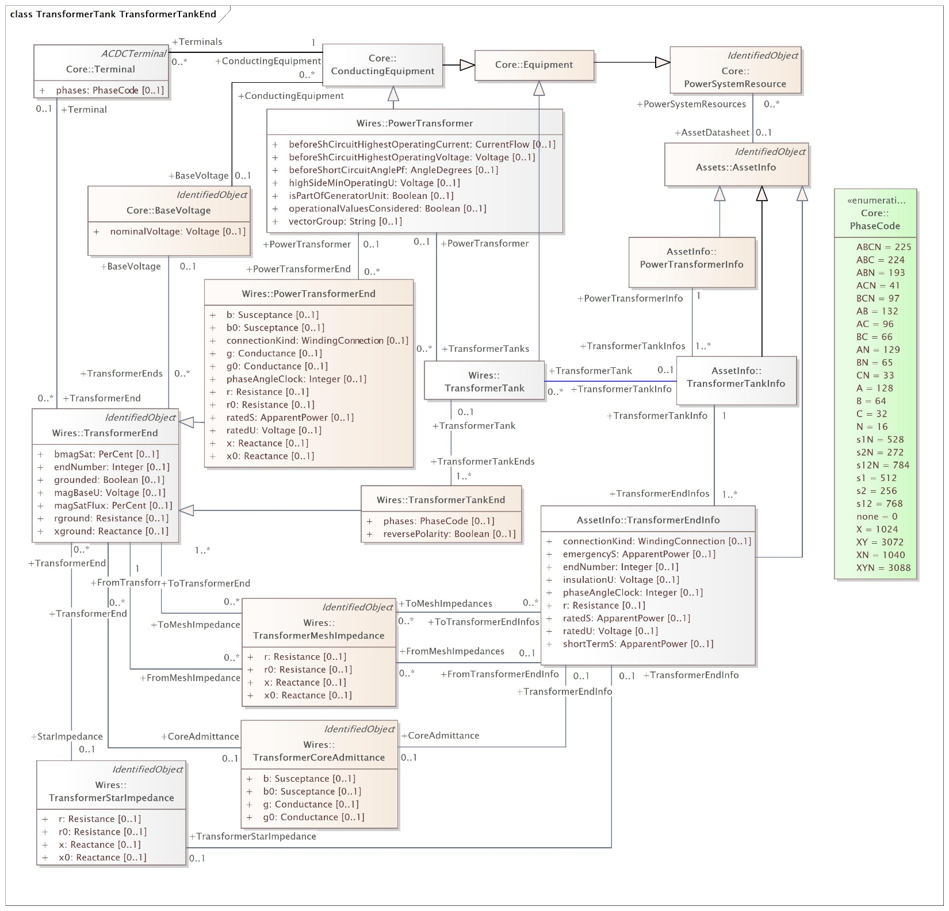

Changes to UML descriptions
Associations

TransformerTankInfo to TransformerTank association
SOURCE TransformerTankInfo
Role: TransformerTankInfo
Transformer tank information for this transformer tank.
Multiplicity: [0..1]
TARGET TransformerTank
Role: TransformerTank
Transformer tank described by this tank information.
Multiplicity: [0..*]

