Proposed Changes to 61970 ACLineSegment modeling for mutual coupling
From the Device Datasheet Breakout Group
30 January, 2022

Changes to UML classes, attributes, and associations
61970 changes
Add class LineSegmentCoupling, a child of IdentifiedObject
with attributes
.coupledLineNumber
.reverseFlow
.xOffset
Add class CoupledLineSegmentGroup, a child of IdentifiedObject
with no attributes
Add association LineSegmentCoupling.ACLineSegment
Add association LineSegmentCoupling.CoupledLineSegmentGroup

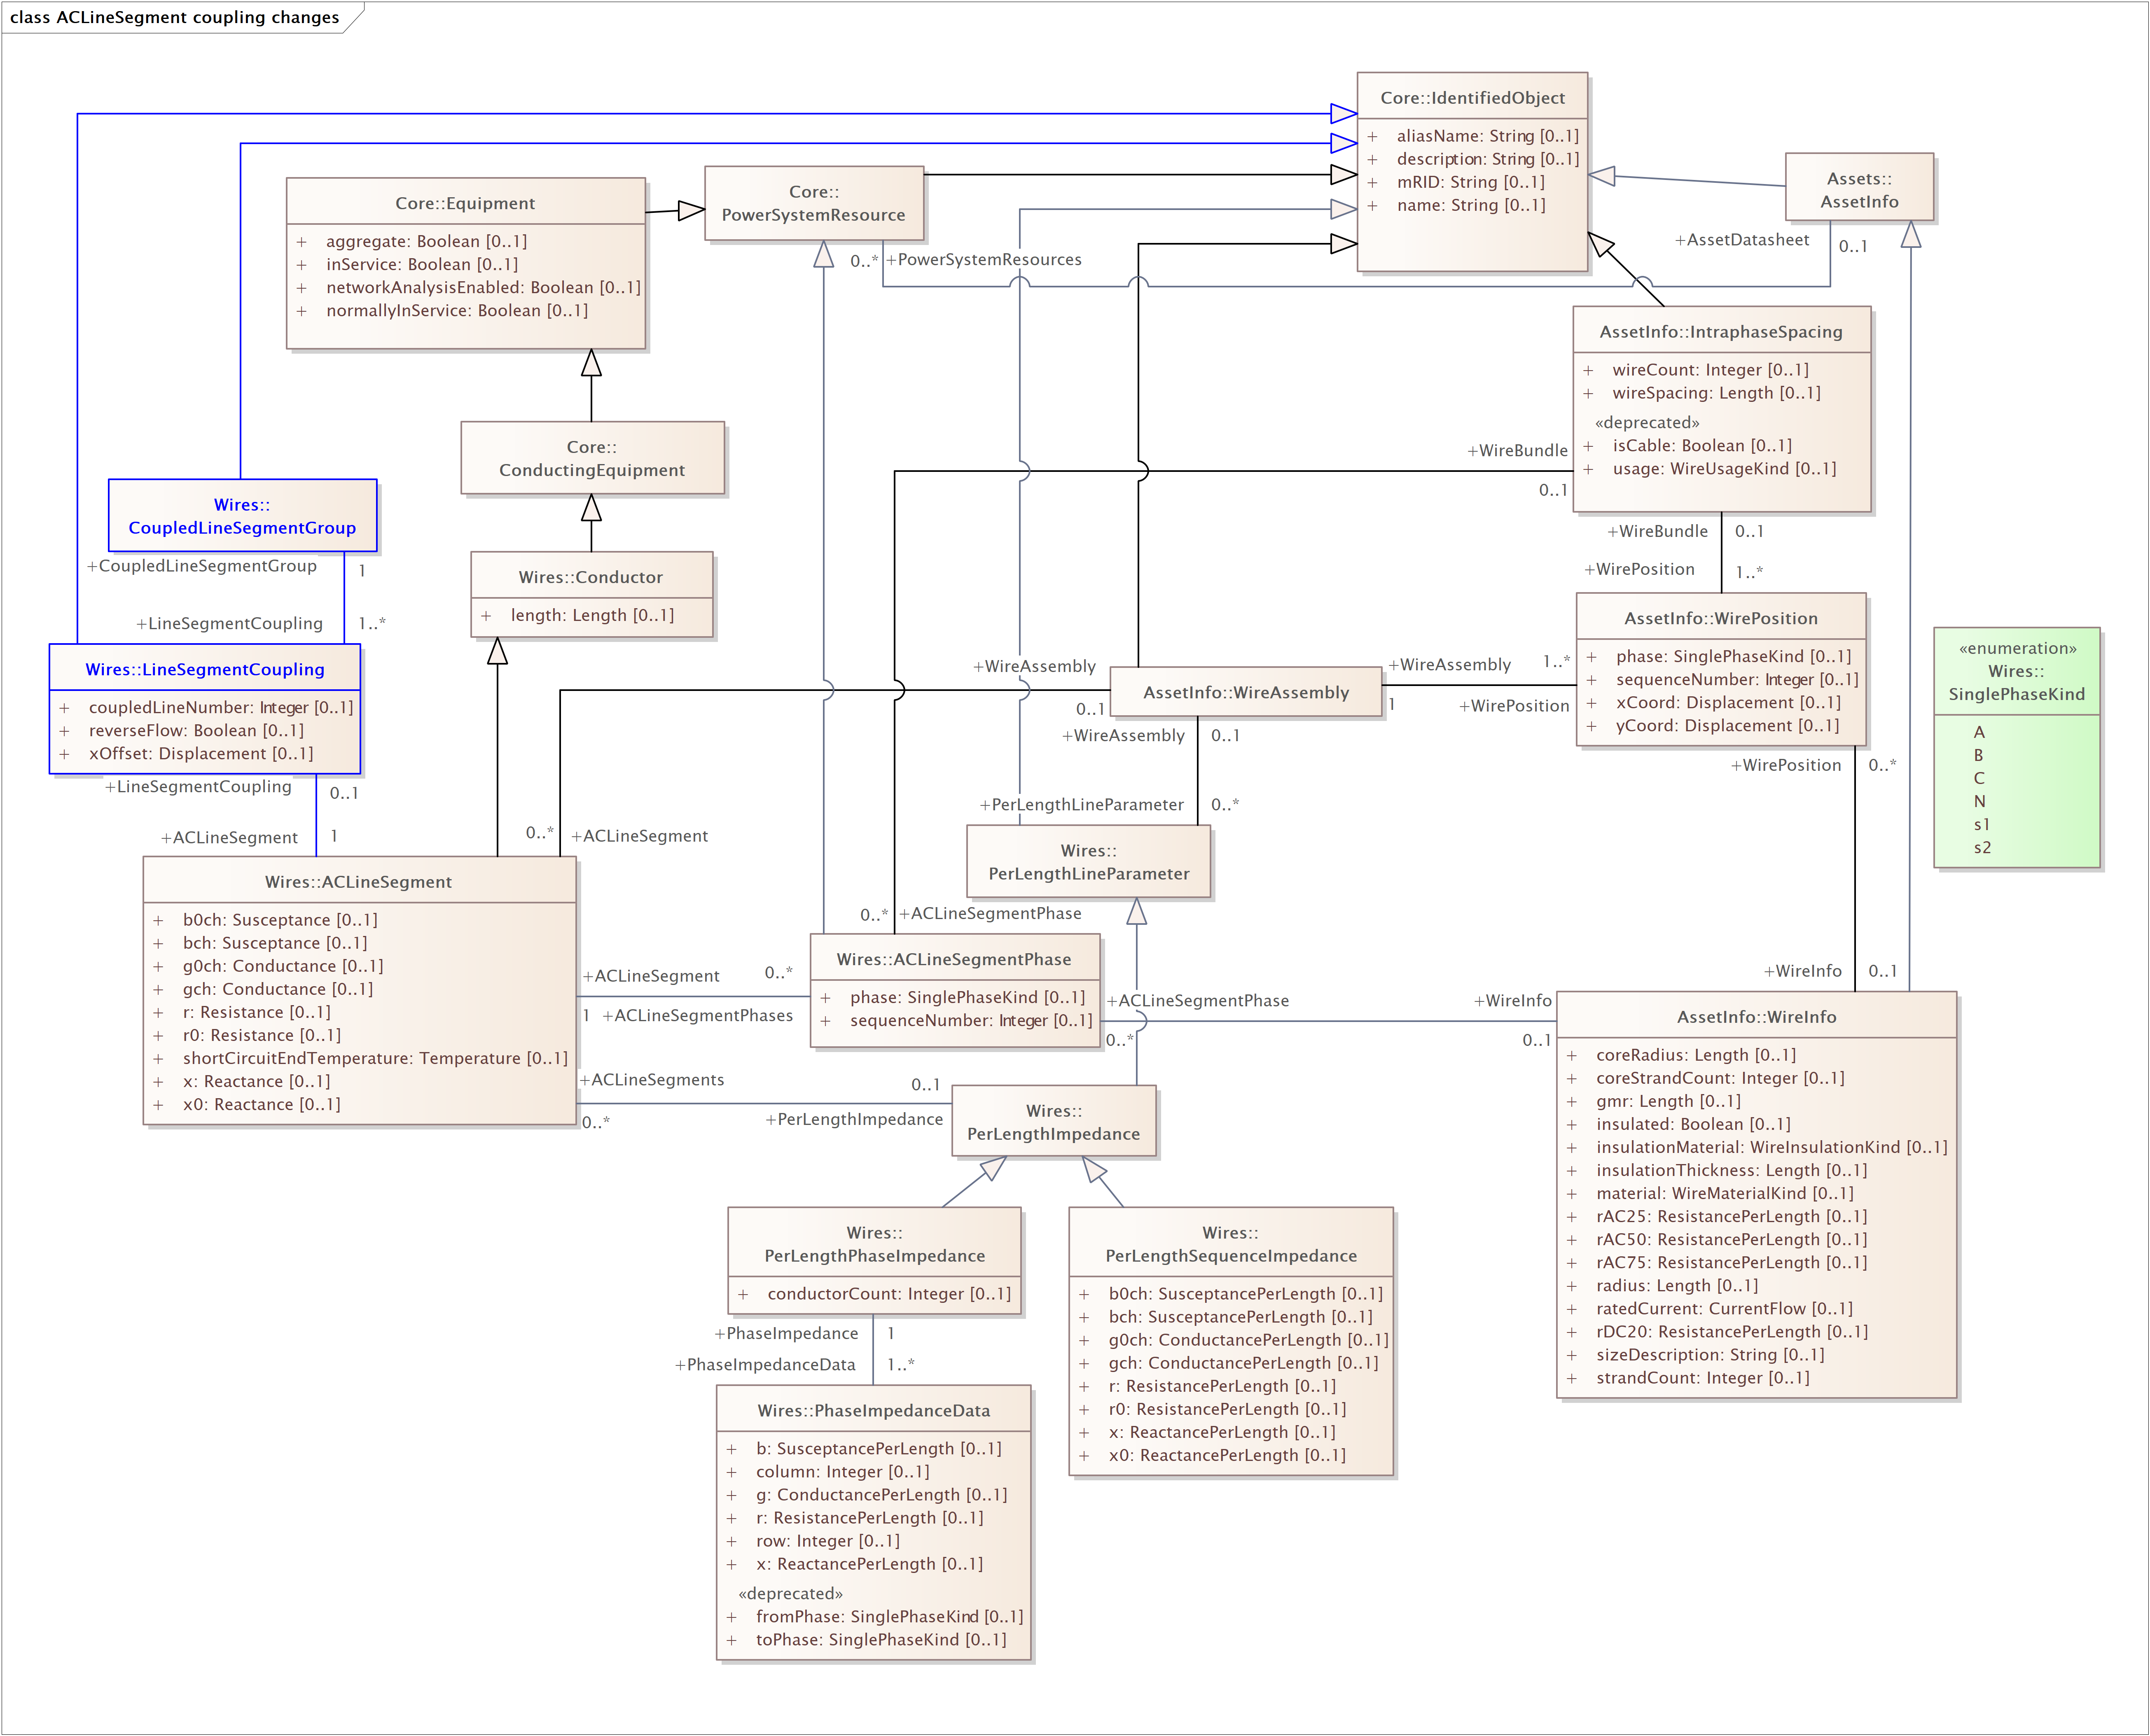

Changes to UML descriptions
Associations

LineSegmentCoupling to ACLineSegment association
SOURCE LineSegmentCoupling
Role: LineSegmentCoupling
The description of this line's coupling with other lines in a coupled group.
Multiplicity: [0..1]
TARGET ACLineSegment
Role: ACLineSegment
The line whose relationship in a coupled group is described.
Multiplicity: [1]

LineSegmentCoupling to CoupledLineSegmentGroup
SOURCE LineSegmentCoupling
Role: LineSegmentCoupling
A coupled line in this coupled group of lines.
Multiplicity: [1..*]
TARGET CoupledLineSegmentGroup
Role: CoupledLineSegmentGroup
The coupled group of lines with which this coupled line has relationships.
Multiplicity: [1]

Classes and Attributes

LineSegmentCoupling
Class in package 'Wires'
Describes the relationship of a line in a coupled group to the reference line in the group. (Reference line has a coupledLineNumber = 1.)

ATTRIBUTES
coupledLineNumber : Integer Public
Multiplicity: [0..1]

Sequence number of coupled line. Value of 1 indicates that line is the reference line. Valid value range is from 1 to number of coupled lines in the group.
reverseFlow : Boolean Public
Multiplicity: [0..1]

Indication of whether the reference end of a line in a coupled group is the same as the reference end of the reference line.
Set reverseFlow to True for any lines that don’t have their Terminal with sequenceNumber = 1 at the same end as the reference line.
Set reverseFlow to False for the reference line and for any lines that have their Terminal with sequenceNumber = 1 at the same end as the reference line.
The sign of the coupled voltage drop of an ACLineSegment reverses when two coupled lines have their Terminals with sequenceNumber = 1 at opposite ends.
xOffset : Displacement Public
Multiplicity: [0..1]

The horizontal offset between the horizontal reference point of a coupled line and the horizontal reference point of the reference line in the group.
The horizontal reference point for a line is established by the line's WireAssembly. It is the zero x position on which the xCoord values of WirePositions in the WireAssembly are based.

CoupledLineSegmentGroup
Class in package 'Wires'
Aggregates a set of line segments that are on the same tower, or in the same right-of-way, close enough that mutual coupling impedances between the lines need to be included in network analysis.

