Solution to #3103

Original:
sCnf121 | Verify the existence of LPHD extension Data Objects: NamVariant, NamHzRtg, NamAuxVRtg, NamHoldRtg and NamMaxDlRtg (table 903) and MaxDl (part 7-4 Ed2 Amd1)  PhyNam.vendor, model, serNum, hwRev, swRev and d are mandatory, not-empty and read-only  PhyNam.serNum the date of manufacture shall be included when not implicit in the serial number (PIXIT: Svp11)  The effective logical node namespace: lnNs = IEC 61869-9:2016[A] | Passed  Failed  Inconclusive  Not applicable

Proposal
sCnf121 | Verify the existence of LPHD extension Data Objects: NamVariant, NamHzRtg, NamAuxVRtg (optional), NamHoldRtg and NamMaxDlRtg (table 903) and MaxDl (part 7-4 Ed2 Amd1)  PhyNam.vendor, model, serNum, hwRev, swRev and d are mandatory and read-only. When read via the IEC 61850 MMS interface the values are not empty.  PhyNam.serNum the date of manufacture shall be included when not implicit in the serial number (PIXIT: Svp11)  The effective logical node namespace: lnNs = IEC 61869-9:2016[A] | Passed  Failed  Inconclusive  Not applicable

No impact on certificate, table A.4.2 not PIXIT

Table 903 from IEC 61869-9 shows NamAuxVRtg is optional:
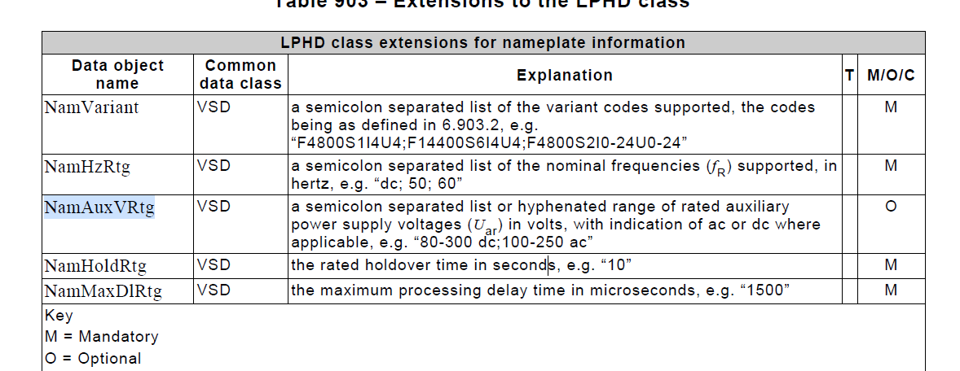
Abstract
- sGos23 Verify that the DUT process GOOSE data values with quality test is true when the device is in test, and ignores such values when device is not in test

sGos23 | Verify that the DUT process GOOSE data values with quality test is true when the device is in test, and ignores such values when device is not in test | Passed  Failed  Inconclusive
IEC 61850-7-4 Annex A
PIXIT Sr5, new PIXIT entry
Expected result
2. and 5. DUT processes the data value flagged with quality test true as described in the PIXIT (for instance: keep last non test value, substitute to a configured value, ...)
Other steps. DUT updates the value and sends a GOOSE message with the changed value
Test description
Test engineer configures the DUT with subscribed GOOSE with FCDA (ping-pong mechanism)

Force the subscriber Logical Node into Beh = on
1. SIMULATOR publishes GOOSE message with changed data values flagged quality test false
2. SIMULATOR publishes GOOSE message with changed data values flagged quality test true
3. SIMULATOR publishes GOOSE message with changed data values flagged quality test false

Force the subscriber Logical Node into Beh = blocked (when supported)
4. SIMULATOR publishes GOOSE message with changed data values flagged quality test false
5. SIMULATOR publishes GOOSE message with changed data values flagged quality test true
6. SIMULATOR publishes GOOSE message with changed data values flagged quality test false

Force the subscriber Logical Node into Beh = test (when supported)
7. SIMULATOR publishes GOOSE message with changed data values flagged quality test false
8. SIMULATOR publishes GOOSE message with changed data values flagged quality test true
9. SIMULATOR publishes GOOSE message with changed data values flagged quality test false

Force the subscriber Logical Node into Beh = test/blocked (when supported)
10. SIMULATOR publishes GOOSE message with changed data values flagged quality test false
11. SIMULATOR publishes GOOSE message with changed data values flagged quality test true
12. SIMULATOR publishes GOOSE message with changed data values flagged quality test false
.
Comment

Add to certificate as mandatory
Add to table A4.2 as mandatory
Add PIXIT entry:

Gs12 | Amd1 | How does the subscriber handle incoming data flagged as test when the destination LN.Beh is On or Blocked?  Is this behavior: | For example:  keep last non test value, substitute to a configured value  etc.  fixed/configurable

